Mission 1 :
Flèche avant : Thymio avance.
Rond central : Thymio stop.

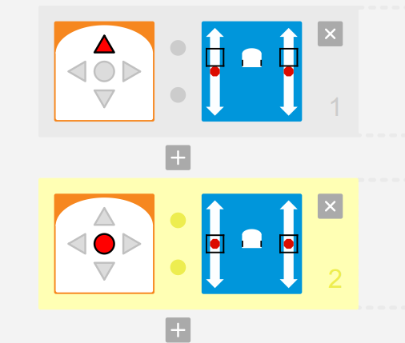
onevent buttons
when button.forward == 1 do
motor.left.target = 200
motor.right.target = 200
emit pair_run 0
end
when button.center == 1 do
motor.left.target = 0
motor.right.target = 0
emit pair_run 1
end
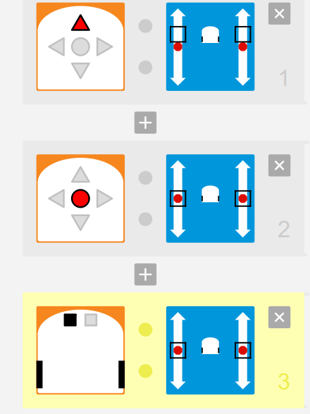
Mission 2 :
Flèche avant : Thymio avance.
Rond central : Thymio stop.
Une surface noire : Thymio stop.

onevent buttons
when button.forward == 1 do
motor.left.target = 200
motor.right.target = 200
emit pair_run 0
end
when button.center == 1 do
motor.left.target = 0
motor.right.target = 0
emit pair_run 1
end

onevent prox
when prox.ground.delta[0] <= 400 do
motor.left.target = 0
motor.right.target = 0
emit pair_run 2
end
Mission 3 :
Flèche avant : Thymio avance.
Rond central : Thymio stop.
Une surface noire : Thymio Thymio recule.

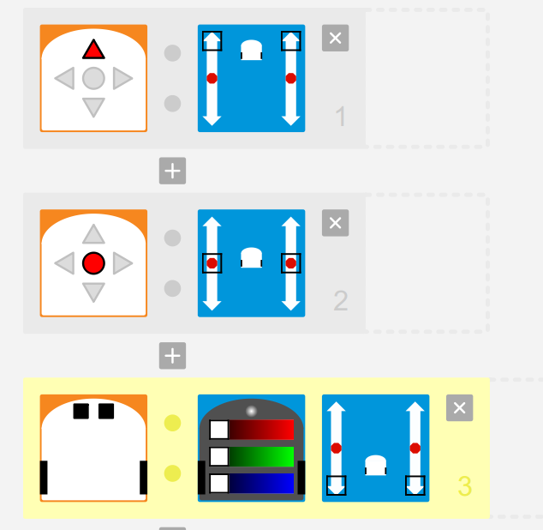
onevent buttons
when button.forward == 1 do
motor.left.target = 500
motor.right.target = 500
emit pair_run 0
end
when button.center == 1 do
motor.left.target = 0
motor.right.target = 0
emit pair_run 1
end

onevent prox
when prox.ground.delta[0] <= 400 and prox.ground.delta[1] <= 400 do
call leds.bottom.left(0,0,0)
call leds.bottom.right(0,0,0)
motor.left.target = -500
motor.right.target = -500
emit pair_run 2
end
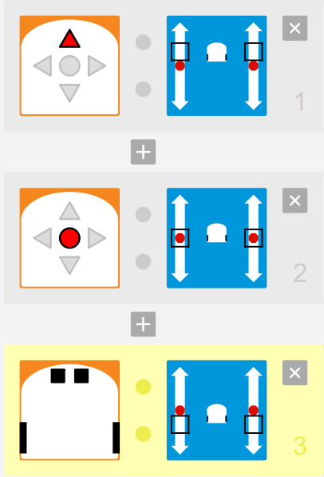
Mission 4 :
Flèche avant : Thymio avance.
Rond central : Thymio stop.
Une surface noire : Thymio recule.
Détection d'un obstacle derrière : Thymio stop.

onevent buttons
when button.forward == 1 do
motor.left.target = 200
motor.right.target = 200
emit pair_run 0
end
when button.center == 1 do
motor.left.target = 0
motor.right.target = 0
emit pair_run 1
end

onevent prox
when prox.ground.delta[0] <= 400 and prox.ground.delta[1] <= 400 do
motor.left.target = -200
motor.right.target = -200
emit pair_run 2
end
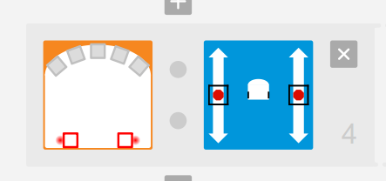
when prox.horizontal[5] >= 2000 and prox.horizontal[6] >= 2000 do
motor.left.target = 0
motor.right.target = 0
emit pair_run 3
end

Mission 5 :
Flèche avant : Thymio avance et est vert.
Rond central : Thymio stop et est rouge.
Une surface noire : Thymio recule et est blanc.
Détection d'un obstacle derrière : Thymio stop et est rouge.

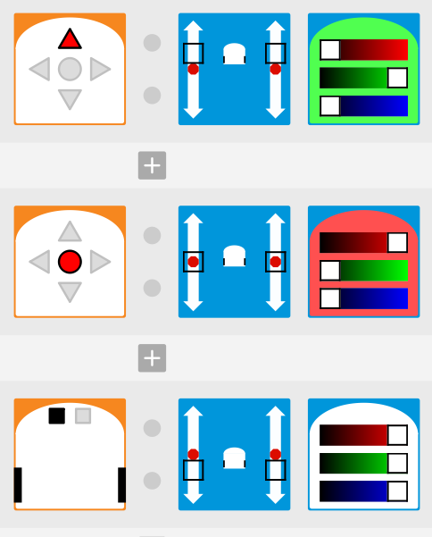
onevent buttons
when button.forward == 1 do
motor.left.target = 200
motor.right.target = 200
call leds.top(0,32,0)
emit pair_run 0
end
when button.center == 1 do
motor.left.target = 0
motor.right.target = 0
call leds.top(32,0,0)
emit pair_run 1
end

onevent prox
when prox.ground.delta[0] <= 400 do
motor.left.target = -200
motor.right.target = -200
call leds.top(32,32,32)
emit pair_run 2
end
when prox.horizontal[5] >= 2000 do
motor.left.target = 0
motor.right.target = 0
call leds.top(32,0,0)
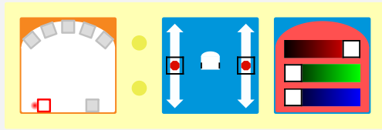
emit pair_run 3
end

Mission 6 :
Thymio suit la limite entre du blanc et du noir.

onevent prox
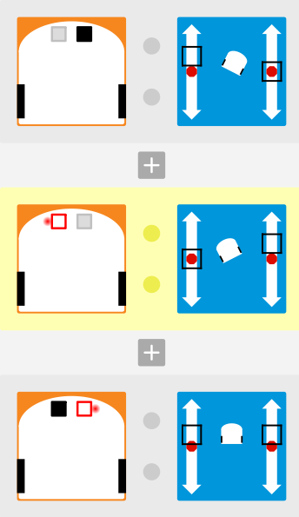
when prox.ground.delta[1] <= 400 do
motor.left.target = 200
motor.right.target = 0
emit pair_run 0
end
when prox.ground.delta[0] >= 450 do
motor.left.target = 0
motor.right.target = 200
emit pair_run 1
end
when prox.ground.delta[0] <= 400 and prox.ground.delta[1] >= 450 do
motor.left.target = 150
motor.right.target = 150
emit pair_run 2
end

onevent buttons
when button.center == 1 do
motor.left.target = 0
motor.right.target = 0
emit pair_run 3
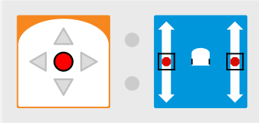
end

