Click here to enter you name

Welcome to our laboratory

Vocabulary lab
1:  2:  3:  4:  5:  6:  7:  8:  9:  10:  11:  12:  13:  14:  15: | Click here to enter text  Click here to enter text  Click here to enter text  Click here to enter text  Click here to enter text  Click here to enter text  Click here to enter text  Click here to enter text  Click here to enter text  Click here to enter text  Click here to enter text  Click here to enter text  Click here to enter text  Click here to enter text  Click here to enter text
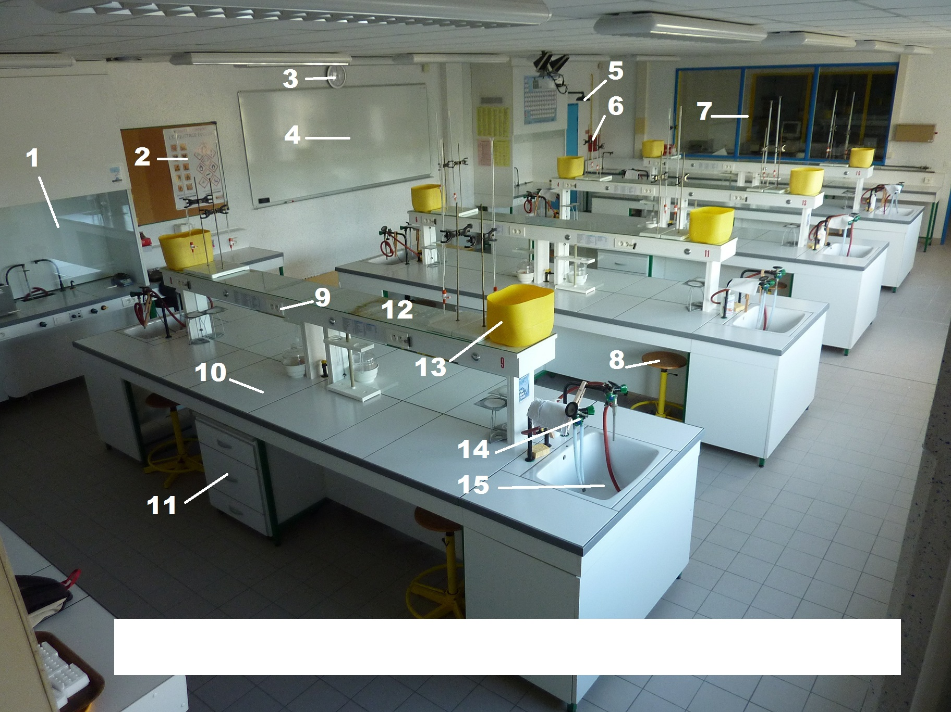

Click here to enter text

Vocabulary lab
1:  2:  3:  4:  5:  6:  7:  8:  9:  10:  11: | Click here to enter text  Click here to enter text  Click here to enter text  Click here to enter text  Click here to enter text  Click here to enter text  Click here to enter text  Click here to enter text  Click here to enter text  Click here to enter text  Click here to enter text
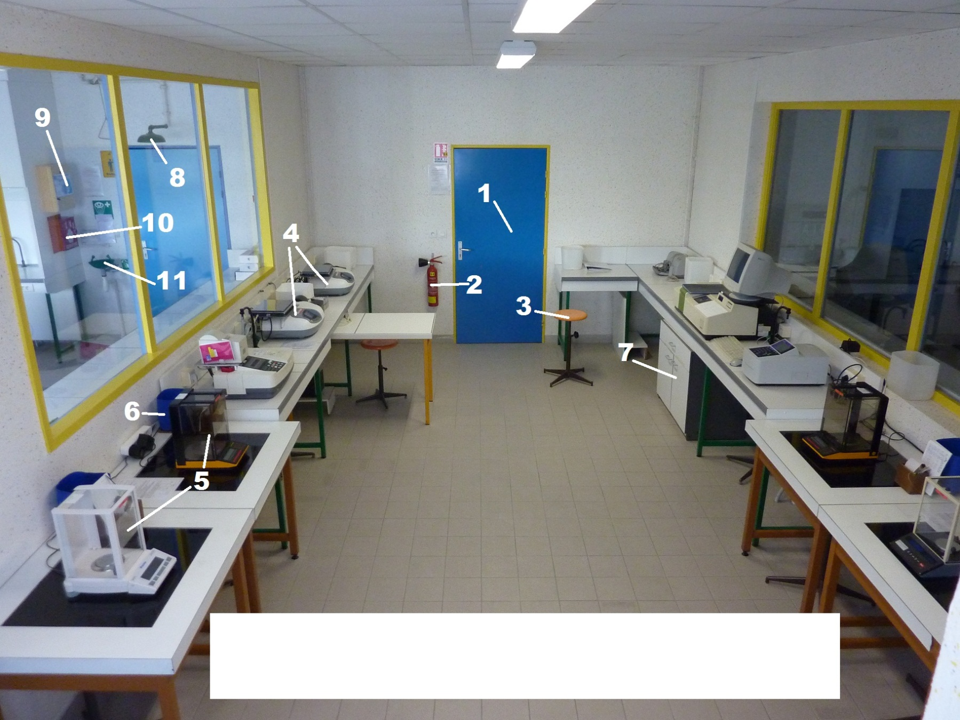

Click here to enter text

Click here to enter text
Click here to enter text
1
2
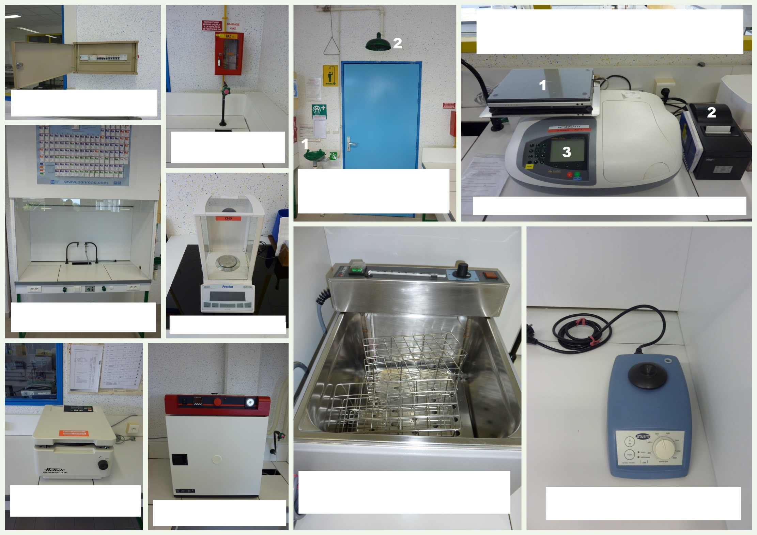

Click here to enter text

Click here to enter text
Click here to enter text
Click here to enter text
Click here to enter text
Click here to enter text
Click here to enter text
Click here to enter text
Click here to enter text
Click here to enter text
Click here to enter text
1
2
3

