Talking about sport.
1 PR
Oral production assessment : presenting an athlete

You are a member of a committee in charge of electing the new athlete of the year.

Prepare your 3-minute oral presentation about the sportsman or sportswoman - either able-bodied or handicapped - you’d like people to discover.
Try to be as convincing as possible in order to win the jury’s votes !

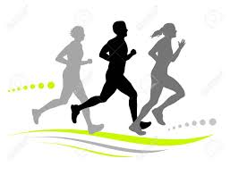
Give the following information :

- Athlete’s full name
- Name of the sport
- Nationality/place of residence
- Age
- Physical description (3 adjectives at least)
- Personality (3 adjectives at least)
- Reasons for his/her success in his/her sport (3 reasons at least)
- Reasons for your choice (3 reasons at least)

- Don't forget to show a picture of him/her.
- You will have to memorize your presentation.
- You will be allowed to use a mind map with a maximum of 10 key words during your oral presentation.
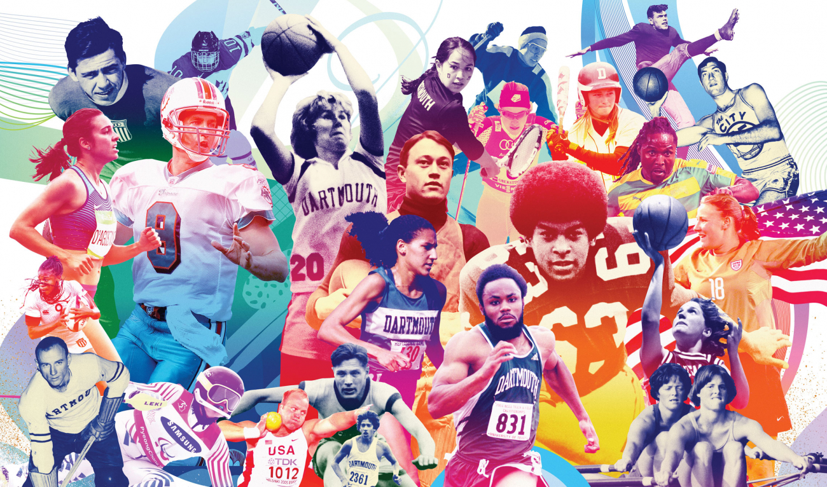

My picture :

My presentation :

