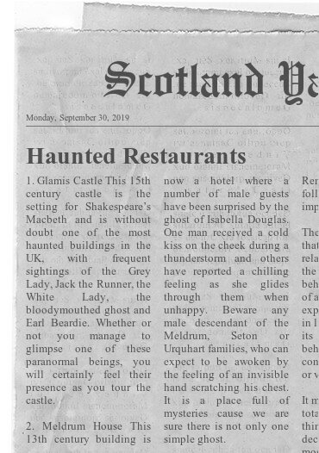

48.862725
2.287592

..............................................................is the ghost
AND wants ..................................................

13-1-14-7-9-14

wHO AM I ?

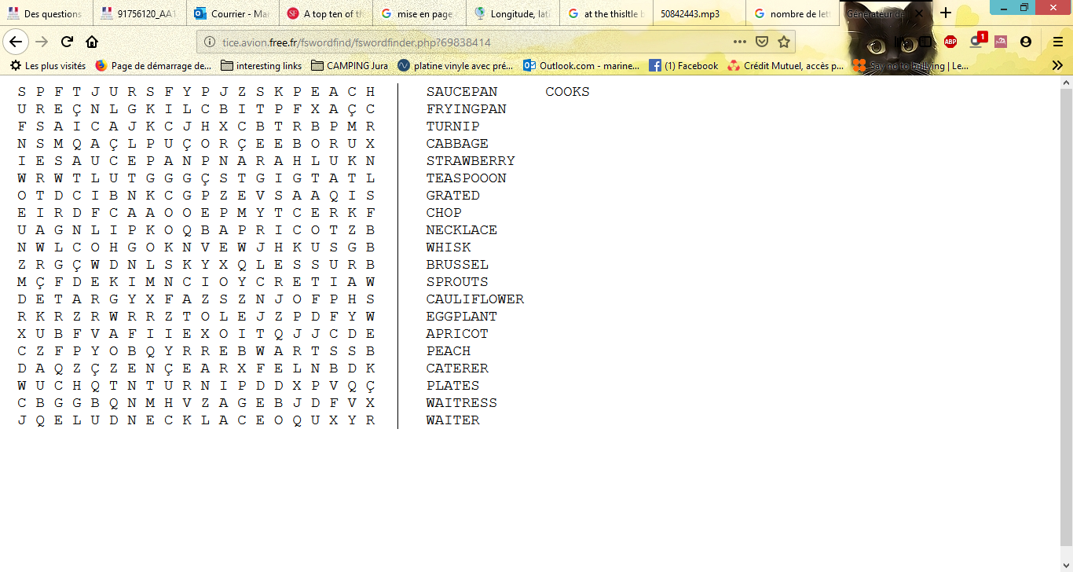

It IS BEHIND A DESK WHERE LOST PEOPLE GO WHEN THEY DON'T KNOW THEIR WAY ! Ask the lady !

