Talking about an issue :
T PR
smartphones and social media

In this sequence, you are going to work on the issue of smartphones and social media and some of their impacts on our lives.

1/ IMPACT 1 : ADDICTION

A/ ENRICHING ONE’S VOCABULARY about addictions (pair work) :

Exercise 1 : Discover the different types of addictions : Underline the words that will help you to fill in the blanks.

a- ………………… addiction refers to compulsive overeating.
b- ………………... addiction is a state characterized by a compulsive engagement in any form of physical exercise, despite negative consequences.
c- ………………... addiction is an uncontrollable urge to overwork despite negative impacts on many areas of a person's life.
d- People suffer from………………... addiction when they need nicotine and can't stop using it.
e- ………………… addiction is a disorder involving compulsive overuse of the mobile devices.
f- ………………… addiction is a game-playing behavior—involving online gaming or offline video games.
g- ………………… addiction is a behaviour that involves compulsive buying.
h- ……………….. addiction is a chronic disorder associated with compulsive alcohol drinking.
i- ……………….. addiction refers to excessive sexual thoughts, desires, urges or behaviours that can't be controlled and cause distress and harm to your relationships, finances and other aspects of your life.
j- Substances involved with ……………. addiction include marijuana, opioids, cocaine, amphetamines etc...
k- A …………….. addiction occurs when a person can no longer control a compulsive gambling behavior — whether racing, bingo, cards,etc...

Exercise 2 : Pick out all the words related to the lexical field of addictions and put them in the right column.
NOUNS / NOUN GROUPS | VERBS | ADJECTIVES | ADVERBS

B/ RECAPITULATION TIME (individual work) :

1- Match the addictions with the corresponding pictures.

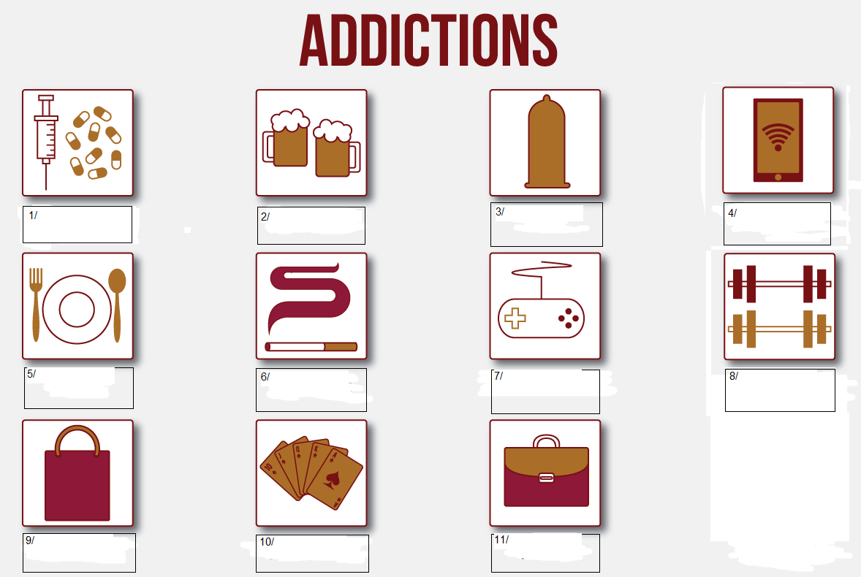

2- Check your knowledge with a vocabulary exercise :
https://www.quiziniere.com/diffusions/6K2P4B
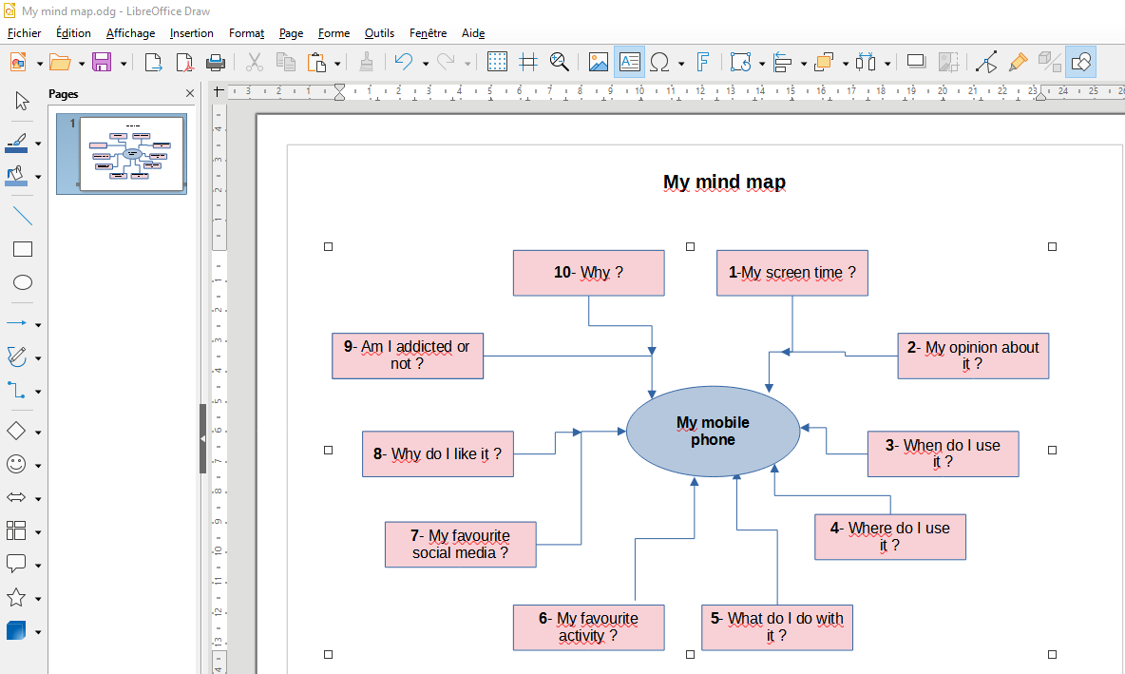
c/ Oral expression : PREparing a 3-minute oral production. (individual work)

QUESTION : What is your personal relationship with your smartphone and social media ?

Step 1 : Answer the following questions and don’t forget to use opinion expressions (click on the link) and the vocabulary of addictions (ex. pages 1 and 2). (individual work)

- - How long do you approximately spend on your mobile phone every day ?
- - What do you think about your screen time ?
- - When do you usually use your mobile phone ?
- - Where do you usually use your mobile phone ?
- - What do you do with your mobile phone ?
- What is your favourite activity ?
- - What is your favourite social media ?
- - Why ?
- - Are you addicted to your mobile ?
- - Why ?

Step 2 : You create your own mind map with the help of ‘LibreOffice Draw’ to memorize your oral ! Add a few notes or key words to make your task easier. (individual work)
Here is an example of what you can do :

IMPACT 2 : AN EDUCATIONAL ISSUE

A/ READING : Read the following document.


Mobile phone use should be banned in schools across England to improve behaviour, the Education Secretary Gillian Keegan announced today.
New guidance from the Department for Education will back head teachers in banning mobile phone use throughout the school day, including at break times, to tackle disruptive behaviour and online bullying while boosting attention during lessons. It aims to support the wider work the government is doing to raise standards in schools by increasing students’ focus and reducing distractions.
This ban supports the hard work of teachers and education staff – and continues to build on government’s reforms backed up by the highest level of funding for schools in history, in real terms, of nearly £60 billion by 2024-25.
The move will bring England in line with other countries that have already implemented a ban, including France, Italy and Portugal. It follows warnings from the United Nations on the risks of smartphones in schools and government data that found around a third (29%) of secondary school pupils reported mobile phones being used when they were not supposed to in most, or all, lessons.
If schools fail to implement the new guidance, the government will consider legislating in the future to make the guidance statutory.

Source : https://www.gov.uk/government/news/mobile-phone-use-to-be-banned-in-schools-in-england Published on 2nd October 2023

B/ UNDERSTANDING THE TEXT.

Exercise 1 : After reading the text, complete the following grid to collect general information.
(pair work)

The document | Type ?
The document | Medium ? | Body/institution ?
The document | Medium ? | Person ?
The topic | Guidance ? | Where ? -  -

Exercise 2 (pair work) :
a- Make a list of the government’s objectives :

-
-
-
-
-
-
-
-

b- Complete the sentences to sum up (pair work) :

a- The government wants the students to be less (adj) and more (adj).
b- It wants to put an end to / ( group noun).
c- The objective is to (verb) the students’ concentration and to
(verb) distractions.

Exercise 3 (individual work):

a- Are these assertions right or wrong ? Click on the link to do the exercise :
https://ladigitale.dev/digiquiz/q/656f5ba754c06

b- Correct the wrong sentences. Click on the link to do the exercise :
https://ladigitale.dev/digiquiz/q/656f67be9b6f4/

c- Correction of the exercises : Tick the wrong sentences and correct what is wrong in them with the help of the text.

Right Wrong
a- Mobile phones have been banned in schools across the UK

b- The principals will be supported by the Department for Education

c- The students will have the right to use their mobiles at lunch time

e- School funding has never been so high according to the government

f- England will come before other countries to implement a mobile phone ban

g- A quarter of students have cheated in class with their smart phones

h-This ban is a law

Exercice 4 : Write an account in French of the document (page 3) you’ve just studied. (individual work)


3/ IMPACT 3 : SMARTPHONES, A SOCIETAL PROBLEM.

UNDERSTANDING A VIDEO :
Click on the QR code or on the link to open the video.
https://www.youtube.com/watch?v=hpeCysxHK2E
Exercise 1: Watch from the beginning of the video to 00:13 seconds and complete the grid.
(individual work)

Type of video
Name of the city
Problem raised

Exercise 2 (individual work) :
Watch from 00:13 to 00:22 seconds and answer the questions with complete sentences.

How often do people look at their phones ?

How long do they spend online every week ?

Exercise 3 (individual work) :

a- Watch from 00:22 to 1:02 seconds and choose the correct assertions.
https://ladigitale.dev/digiquiz/q/6571ec2f0eafb/

b- Correction of the exercise (individual work) :
a- The girl sometimes uses her phone The girl has her phone wherever she goes
b- The boy usually checks Facebook at work The boy checks Facebook when he is not working
c- The woman is just responding to messages The woman is going to respond to messages
d- The study showed there aren’t taboos The study showed there are taboos
e- People under 55 find it rude to check a phone during a meal People over 55 find it rude to check a phone during a meal
f- People under 35 are offended too People under 35 aren’t as offended
g- It is important to find a solution It is important to find a balance

Exercise 4 (individual work) :

a- Complete the sentences with the right words.
https://ladigitale.dev/digiquiz/q/6571f99a9b9da/

b- Correction of the exercise :
a- Ten years ago we had many different .
b- We had to listen to music,
c- We had to take us around.
d- Today all of that is into one device and now 8 in 10 of us
a smartphone and really spend lives on that smartphone.
e-To ease that some including Facebook and Instagram are introducing new to limit how much time a user can spend on the and just maybe that'll get people to stop and look up !

Exercise 5 : Exam training : Write an account in French of the video you’ve just studied in 20 minutes. (individual work)

4/ DEBATING : Now let’s debate to exchange your views on the following question (group work) :
Are smartphones and social media good or bad for society ?

- Group 1 (6 students) : You have 20 minutes to :
- Find out 6 arguments in favour of smartphones and social media :
1/ at school ( 2 students)
2/ at work ( 2 students)
3/ on holiday ( 2 students)
- Give 6 concrete examples to illustrate your arguments.
- Sum up your viewpoint (= in favour) in one sentence

- Group 2 (6 students) : You have 20 minutes to :
- Find out 6 arguments against smartphones and social media :
1/ at school( 2 students)
2/ at work ( 2 students)
3/ on holiday ( 2 students)
- Give 6 concrete examples to illustrate your arguments.
- Sum up your viewpoint (= against) in one sentence

Usefull expressions :

Firstly = premièrement
Secondly = deuxièmement
Thirdly = troisièmement
To begin with... = pour commencer/tout d’abord…
In addition to this / Furthermore / Moreover = en plus/en outre
to feel that = penser/estimer/avoir le sentiment que
To believe that = croire/penser que
To think that = penser que
I want to mention that = je veux mentionner que

I want to say that = je veux dire que

It’s important to remember that : il est important de rappeler que

To agree = être d’accord

To disagree = ne pas être d’accord

Yes, perhaps, however... = oui, peut être, cependant
Well, yes, but … = Eh bien, oui, mais
Yes, in a way, however... = oui, d’une certaine manière, cependant
Hmm, possibly, but ...= hum, peut être, mais
Yes, I agree up to a point, however ...= oui, je suis d’accord jusqu’à un certain point, cependant

To share a point of view-a viewpoint = partager un point de vue

To sum up = pour résumer
To conclude = pour conclure
Finally = enfin
In a nutshell = en résumé/en bref/en un mot
To recap the main points… = pour récapituler les points principaux
Let’s sum up where we stand in this debate / Let me summarize our position in this debate. = résumons notre position dans ce débat
In summary, we want to point out that… = en résumé, nous voulons souligner que

- Group 1 (2 students) will start and put forward 2 arguments in favour of smartphones and social media at school
- Group 2 (2 students) will respond with 2 arguments in against of smartphones and social media at school
- The debate will continue with arguments for and against smartphones and social media at work and on holiday
- Each group will conclude the debate with one sentence to summ up their view(s)
- Conclusion Class activity : Finding a closing argument that could get everyone to agree and suggesting improvements.

