My Mood Meter

Using the mood meter on the board, produce a mood meter in pairs using the adjectives you know. Drawing your own mood meter will help you to make it your own and to understand how it works.

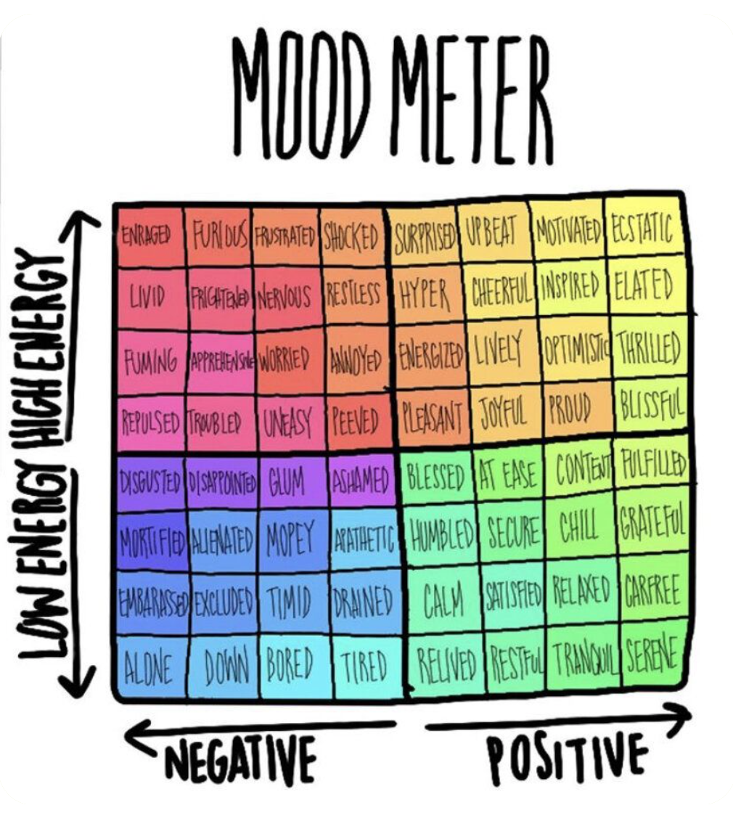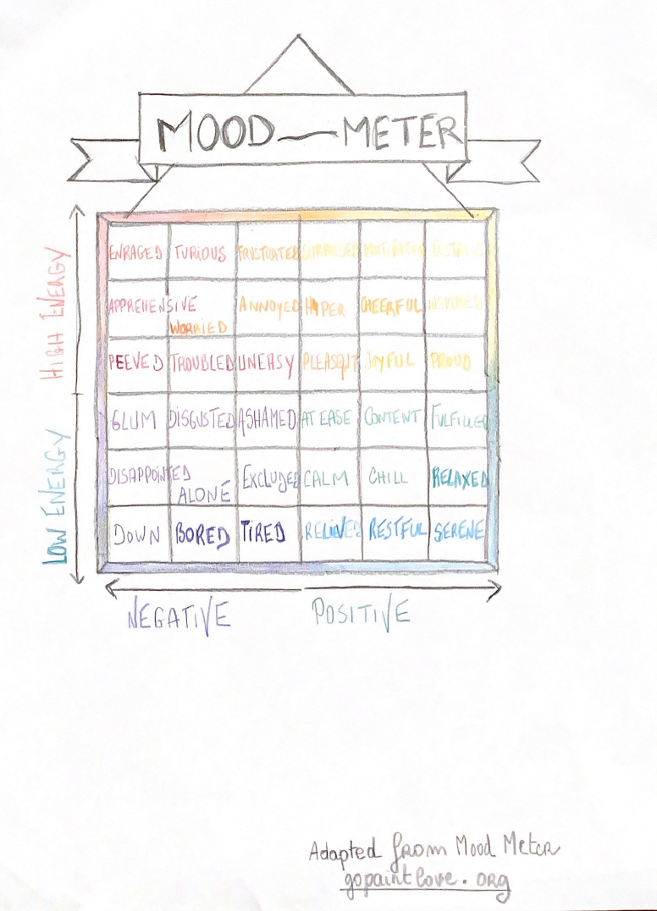

Speaking

Spot useful adjectives in your Mood meter to describe Jesse's emotions.

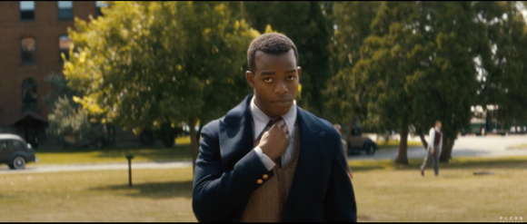 | HIGH ENERGY-NEGATIVE =uneasy  I think he is uneasy because it is his first meeting with his coach.  HIGH ENERGY-POSITIVE =proud  He is nervous and proud at the same time.In the film, you can see that he is shaking his leg when sitting. |  | 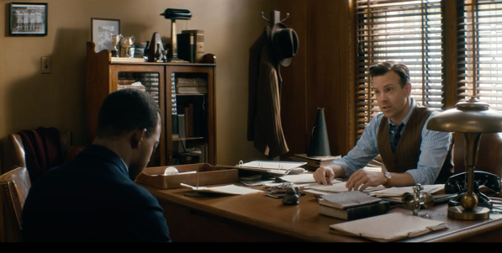
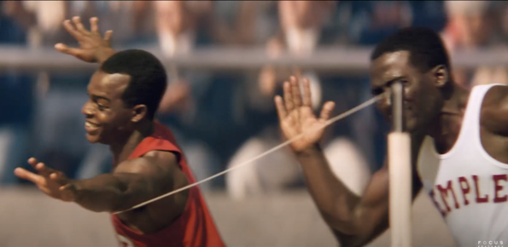 |  |  | 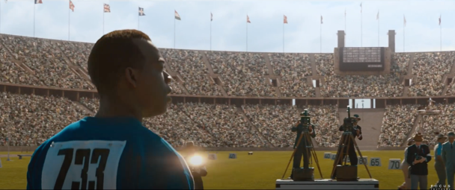
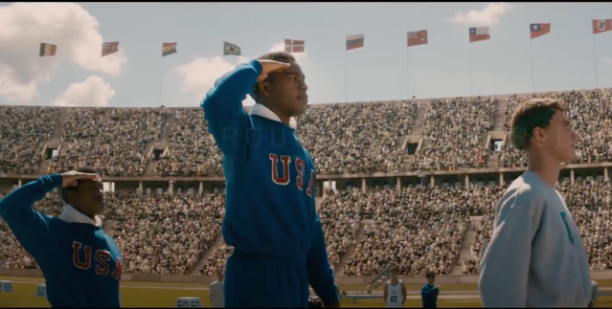 |  |  | 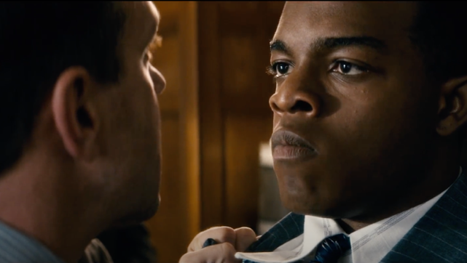

Reading

Jesse Owens's interview
By student1s on 24 January 2017, 21:00 - Permalink
The period between two wars (1918-1939) has been marked by an event in the sport world and in particularly in Germany, governed by Hitler who became chancellor of the 3 Reich. Jesse Owens a grandson of a slave, a black American had won the Olympic Games in Berlin in 1936 as runner of discipline of track and field. We had the opportunity to interview this new famous runner.

What do you think about the movie "Race" which explain your way since the beginning?
"I think that movie explain very good my life and career. Traces many truthful elements of my life, my career and my journey in general, my add-on for the race and my successes from my beginnings in college, to my training and friendship with my coach and my friend Larry. After such as the many competitions and finally the Olympic Games in Berlin. A great competition!"

The Olympic Games in Berlin were an event that marked your sporting career, how you felt and what was your reaction to your victory?
"In truth I was extremely enthusiastic and also very impresses with the idea of being present. I was confident only to be present and to participate in these Games."

What embody this victory for you?
"It's mean a lot of. First it was a big reward for all my work and then it was a furthermore in black and so it was very difficult for the black people to participate at the Olympic Games."

We thank Jesse Owens for participating in our interview.

http://blog.ac-versailles.fr/1sjj/index.php/post/24/01/2017/Jesse-Owens-s-interview

( 1153 caractères )

Track your mood

In today’s life, no one is free from stress. The reason for it may vary from person to person.
For some, it could be work related, whereas, for others, it could be personal. And to a certain level, it’s normal. However, the problem arises when it starts to get exaggerated. If-you’re facing a similar issue, don’t worry. A mood tracker can help. Let’s find out how.
https://www.youtube.com/watch?v=jMJZd45NTjo

A mood tracker is basically a tool that helps you regulate your mood at regular intervals.
The primary purpose of this tool is to find your mood patterns from time to time and determine how your state of mind changes according to circumstances and situations.
Fill out your mood tracker page or online app !
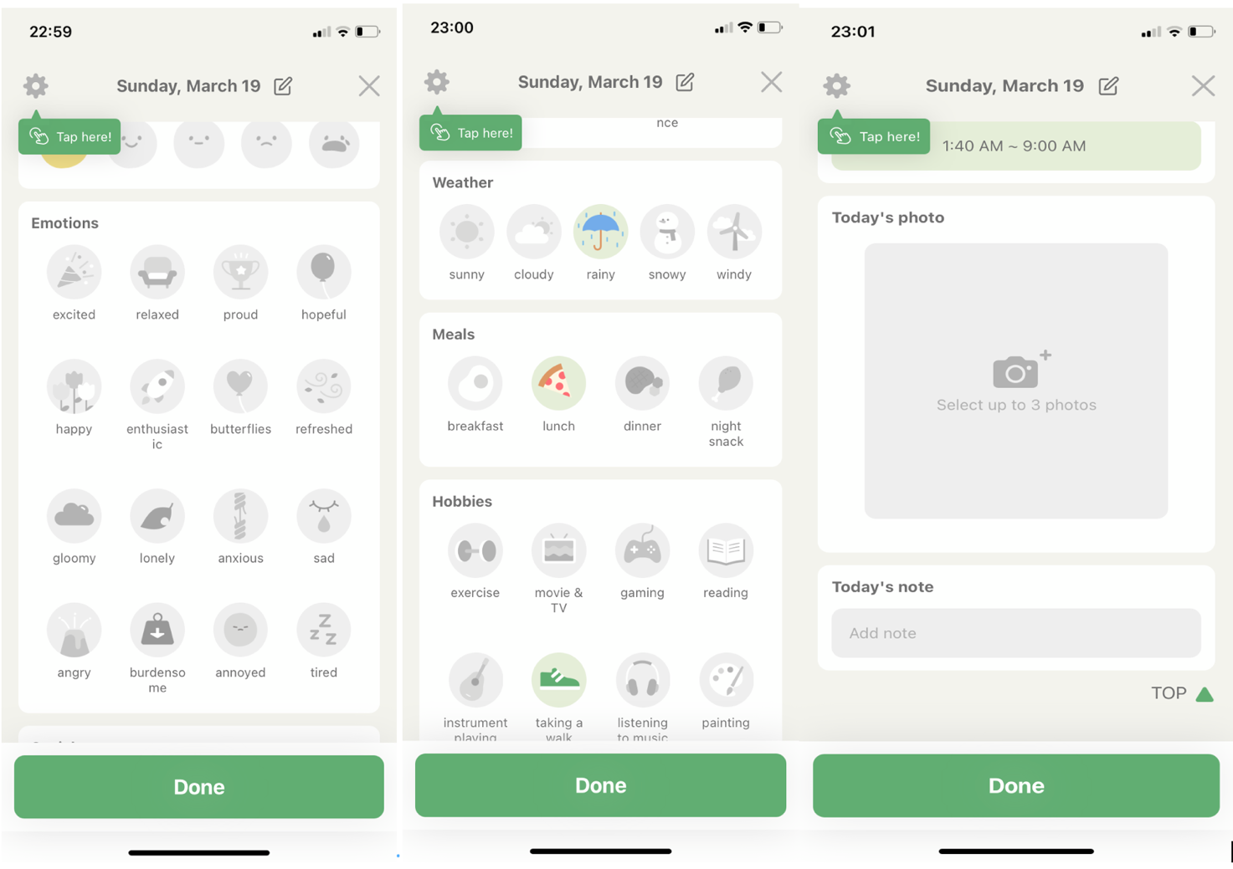
Your turn !
Circumstances : Today, the weather was rainy.
Immediate feeling : I was feeling relaxed.

Situation : I had lunch before taking a walk.
I went to a concert.
Secondary feelings : I was excited to see my friends.

Writing
You had a tough experience, something difficult you had to do, or you experienced a conflict, you had to make a difficult decision... You may want to think of cases from school, sports teams, volunteer or internships ! Record the circumstances, the emotions you felt that day and the activity that caused the emotion.

Example :

Circumstances | When I was a kid, coming back from school, I broke my hand
Immediate feeling ( adjectives ) | It was painful.
Effects | And I couldn’t continue playing basketball and at school I had to write with my left hand
Secondary feelings | It was very frustrating.
Overcoming | But I practiced left-handed layups so I’d be ready to return to playing basket-ball.
What was learned | This experience taught me to be persistent and patient. And how to use my left hand.
70 words
Your turn :

Background
Immediate feeling
Effects
Secondary feelings
Overcoming
What was learned

