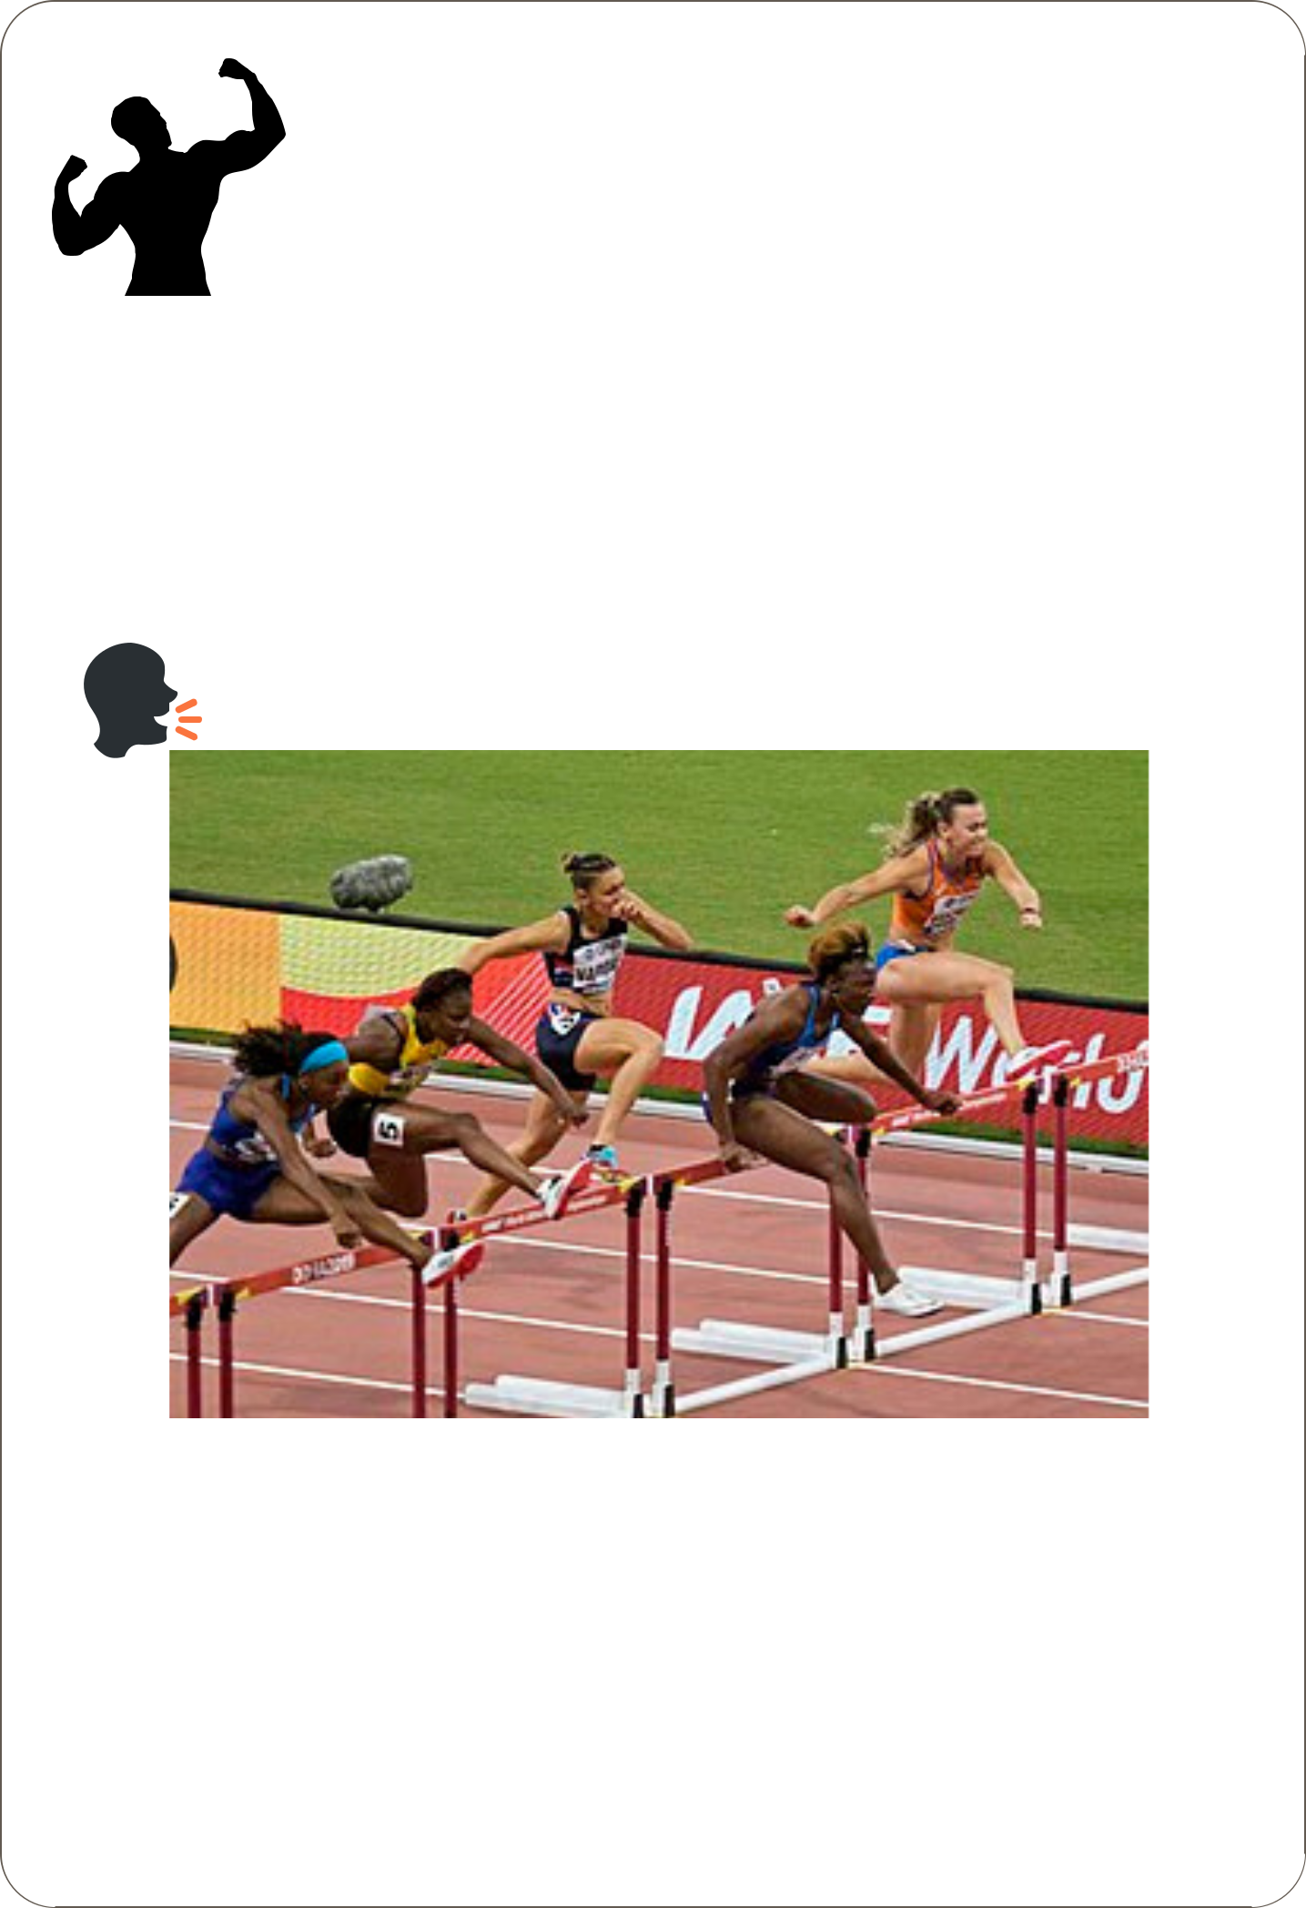
A good mix ? !

Lesson 1: Entering the sporting world

Activity 1:

> Speak about this picture !

100m hurdle final- 2019 World Championship

-----------------------------------------------------------------------------

-----------------------------------------------------------------------------

-----------------------------------------------------------------------------

-----------------------------------------------------------------------------

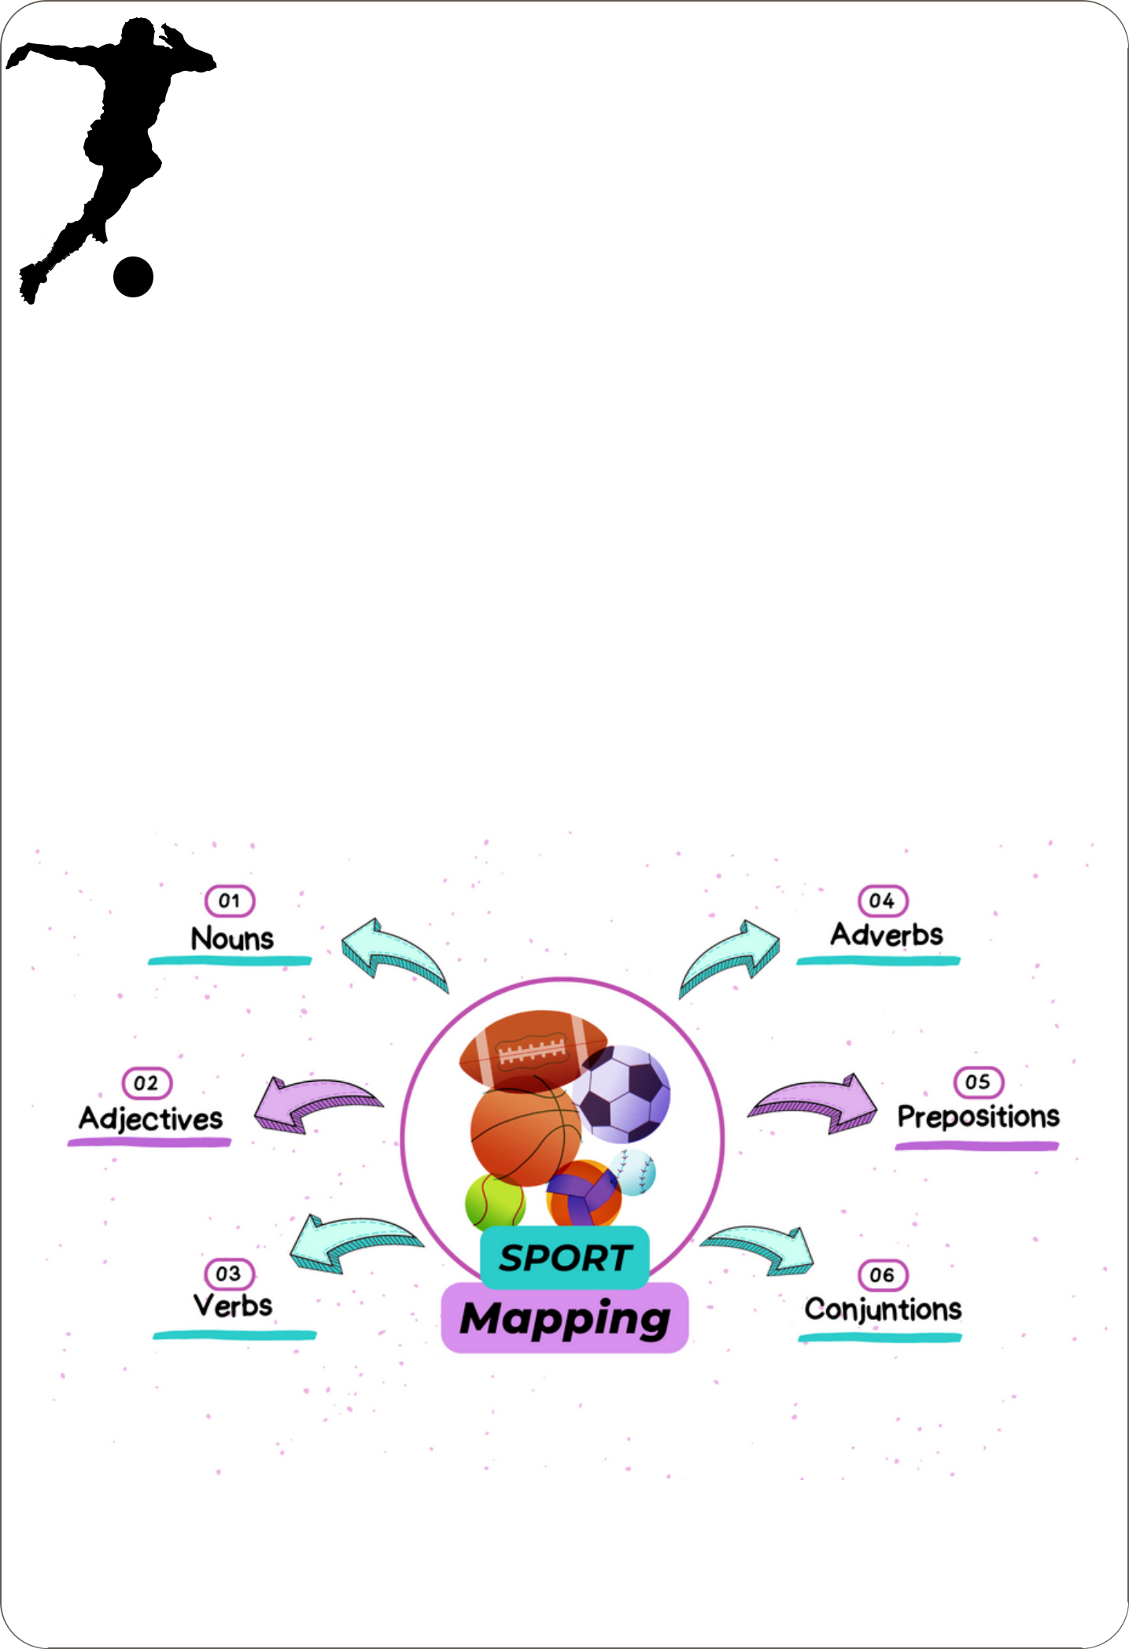
A good mix ? !

Lesson 1: Enter the sporting world

Activity 2:

- In groups of 3 or 4, create a vocabulary mind map about sport. Get inspired with the model below.

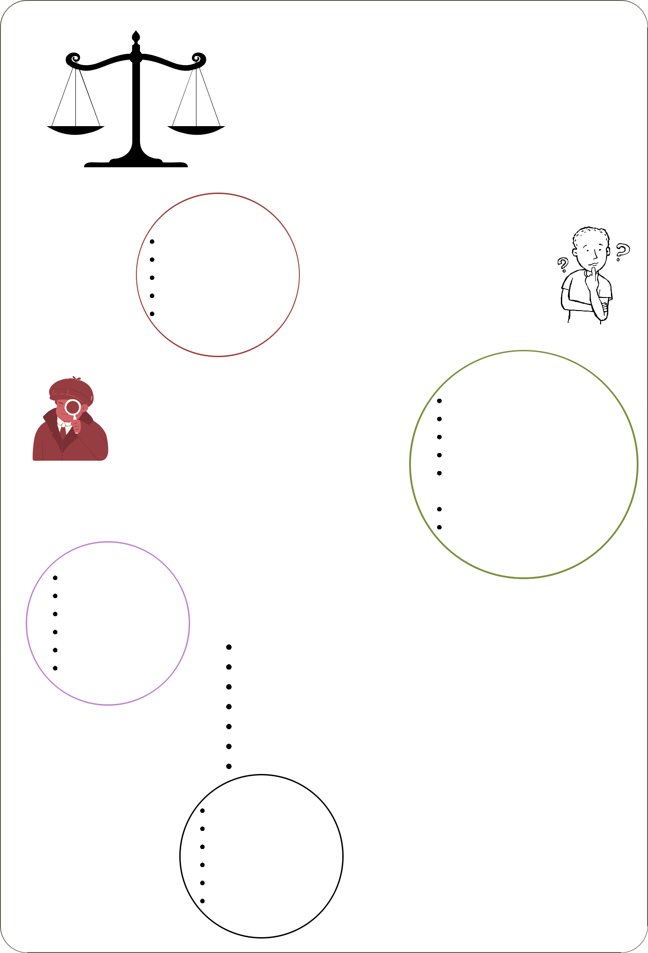
A good mix? !

Activity 3:

referee/umpire

rule

spectator

stadium

success

Trouve l’antonyme dans cette liste:

1- win

2- victory

3- the starting line

4- failure

Donne autant de possibilités que possible pour compléter ces amorces:

1- you can win a ...
2- you can ... a game.
Trouve l’antonyme dans cette liste:

3- spectators can ...

championship

contestant

defeat

entry fee

final

finish line

game/match

practice

fame

team

tournament

coach/

victory

world record

Donne les noms qui sont issus de ces verbes --> traduis-les:

train --> | -->
support --> | -->
win --> | -->
begin --> | -->
own --> | -->
start --> | -->
lose --> | -->
applaud
beat
lose
score a point
travel
earn money

A good mix? !

Lesson 2: Sport marketing

Activity 1:

> Tick the right answer from the slideshow

(https://www.canva.com/design/DAFtAOFPG3U/TsU5WrWlmMQRg6RJG_JeyQ/view?

utm_content=DAFtAOFPG3U&utm_campaign=designshare&utm_medium=link&utm_source=

publishsharelink)

STATEMENT 1:
a- $ 250 billion |  | b- $ 2 billion
STATEMENT 2:
a- ticket sales and TV broadcast rights |  |  |  | b- the sales of magazines, games and clothes
STATEMENT 3:
a- soccer | b- football |  | c- baseball
STATEMENT 4:
a- American football |  | b- tennis |  | c- cricket | d- baseball
STATEMENT 5:
a- the Super Bowl |  | b- the US open |  | the NBA final
STATEMENT 6:
a- 1h | b- 30 minutes |  | c- 30 seconds
STATEMENT 7:
a- 4,000 tons of tortilla chips |  |  | b- 4,000 tons of popcorn and 14,000 tons of potato chips
STATEMENT 8:
a- advertisements |  | b- art exhibitions

A good mix? !

Lesson 2: Sport marketing

Activity 2:

> Read the text to recap in French:

A NATION OF BOOKMAKERS

Bookmaking is illegal in many countries, including the USA, but it is legal in the United Kingdom where there are about 8,500 betting* (pari) shops.
Betting shops are everywhere. Placing a bet on Manchester United is as easy as getting a haircut or buying bread. Bets are also taken via the Internet or phones, with SMS. On the Internet, there are many popular sports betting forums where members exchange information.
Most of* (la plupart) the bets at betting shops are on sporting events. The English are passionate about football- which attracts* (attirer) the majority of betting interests- but they also bet on cricket, rugby, tennis, golf...
The British will bet on anything* (n’importe quoi): the probability that man will land on Mars, or that it will snow on Christmas Day, or the outcome* (le résultat) of political elections, or the winner of reality television contest such as* (tel que) “I’m a Celebrity”, “The X-Factor”...

________________________________________________________

________________________________________________________

________________________________________________________

________________________________________________________

________________________________________________________

________________________________________________________

________________________________________________________

________________________________________________________

________________________________________________________

________________________________________________________

A good mix? !

Lesson 2: Sport marketing

Activity 3:

> Watch the video to recap in French: “Dream Crazier” (2019-Nike)

- Remember to identify: title, source, date and subject in the introduction;

- Don’t forget to discuss TWO important problems in what you understood;

- To finish, use the conclusion to speak about the author’s goal to create this video.

___________________________________________________________________

___________________________________________________________________

___________________________________________________________________

___________________________________________________________________

___________________________________________________________________

___________________________________________________________________

___________________________________________________________________

___________________________________________________________________

___________________________________________________________________

Write 10 lines in English to give your vision of fame and money in the world of athletes.

____________________________________________________________________________________________________

___________________________________________________________________________________________________

___________________________________________________________________________________________________

___________________________________________________________________________________________________

___________________________________________________________________________________________________

___________________________________________________________________________________________________

___________________________________________________________________________________________________

__________________________________________________________________________________________________

A good mix? !

Trainings

OBSERVE THE FOLLOWING SENTENCES:

I think a sportsman is someone who personifies the real values of sport.

Sport is something which/that requires physical ability.

Identifiez le pronom relatif dans chacune des phrases.

Dites quelle est sa fonction.

Justifiez le choix pour chaque pronom relatif.

Selon vous, les deux énoncés sont-ils ...

=> des exemples ?

=> des suppléments d’informations ?

=> des définitions ?

Exercice 1: Reliez les phrases avec un pronom relatif:

1- Myron is being interviewed by a journalist. This journalist works for Sports

Illustrated.

2- Some athletes are treated as rock stars. They think they can live above the rules of

society.

3- Myron won a scholarship. This scholarship enabled him to go to Oxford.

4- Myron works hard to prepare for his exams. He will take these exams in June.

Exercice 2: Ecrivez des définitions avec les amorces suivantes:

- a referee is ... (supervise)

    - a coach is ... (train)

  - a rule is ... (be obeyed)

A good mix ? !

Lesson 3: What’s to be a

famous sportsperson ?

Activity 1:

- Look at the documents to answer the following missions. Mission 1: Who is this person ?

With the picture and the caption, guess who is this man.

What can you guess from his job, his life.

With this presentation, write some key words.

Mission 2: In the interview, pick out...

4 nouns at the end of Myron’s second answer;

3 of them have corresponding adjectives: give them; synonyms in the text:

--> (Q&A 1): revenue --> (Q&A 3): formidable/conscious

--> (Q&A 5): exercise/approaching/ manage to find time for

The Rodes Scholarship have brought

outstanding students from many countries

Mission 3: Read the text to find answer to... around the world to the University of

Oxford since 1904.

(Q&A1): Vrai ou faux ? “En choisissant d’aller à Oxford, Myron a fait beaucoup d’argent.”

--> Expliquez et justifiez votre réponse + expliquez la raison de son choix.

(Q&A2): donnez les valeurs du sport, selon Myron.

(Q&A3): comment devraient vivre les athlètes, selon lui ? pourquoi ?

(Q&A4): qu’est-ce que le journaliste admire chez Myron? quels sont les plans de Myron pour l’avenir?

(Q&A5): dites les 4 choses que Myron fait quotidiennement.

(Q&A6): quelle est la seule chose qui le rende triste?

A good mix ? !

Lesson 3: What’s to be a

famous sportsperson ?

Activity 1:

Myron Rolle, a student athlete

Journalist: when you chose to study at Oxford University rather than play football immediately, you knew it would you cost you millions of dollars in potential earnings.

Myron Rolle: yes, but it’s such a great opportunity. I didn’t want to miss it !

----------------------------------------------------------------------------------------------

Journalist: what is your definition of a sportsman ?

Myron Rolle: I think a sportsman is someone who personifies the real values of sport:

discipline, integrity, passion and competition.

----------------------------------------------------------------------------------------------

Journalist: oh yes ! In football, we had examples of athletes with very poor judgement ! Now, you said that you wanted to eliminate the stereotype that athletes are stupid. Can you explain ?

Myron Rolle: yes. I want to show that you can be a top athlete and succeed in university. You see, after my NFL career, my dream is to become a doctor and open a clinic for the poor in the Bahamas.
----------------------------------------------------------------------------------------------

Journalist: what is typical day like for you at Oxford ?

Myron Rolle: well, lots of hard work. I do about three hours of physical workout* (musculation) each day-- plus all the lectures and research for my upcoming essay.* (examen) My day starts at 6:30 iin the morning and I go to bed around 11 p.m. But I do manage to squeeze in social time.* (caser)
----------------------------------------------------------------------------------------------

Journalist: what do you miss most about the U.S ?

Myron Rolle: I miss seeing my family the most. Now, an ocean separates us.

----------------------------------------------------------------------------------------------

From Sports Illustrated, 2009-2010.

A good mix ? !

Lesson 3: What’s to be a

famous sportsperson ?

Activity 2:

PRESENT YOUR SPORTSPERSON

Remember to:

1- speak using the photos and the notes;

2- have an eye-contact with the audience;

3- justify your choice.

Activity 3:

GIVE YOUR OPINION ABOUT THE PRESENTATION OF A SPORTSPERSON

When you give your opinion, don’t forget that:

1- it can be difficult to speak from notes;

2- it can be uneasy to be standing in front of an audience;

3- it is necessary to be as fair as possible.

Your opinion is part of advice to help your mates improve for the exam !

A good mix ?!

Assessment

Skill 1: Recap a text in French.

Find the title, source and date, the subject of the text and the main idea developed in the document.

Amir Khan Opens Gym

Former* (ancien) Olympic champion Amir Khan has become a professional boxer. Now, at 25, he has put £700,000 of his money into a boxing gym in Bolton, near Manchester.

Can you tell us why you put money into this project ?

What I want to do is get the kids off the streets of this area. You see, there’s a lot of vandalism, throwing stones and graffiti. I think boxing can teach kids discipline. I started out like many of them. I was a bit hyperactive when I was young. Going to a boxing club kept me out of trouble.* (en dehors des ennuis)

You are a role model for these youngsters.* (jeunes gens) When they see your nice clothes and your nice car, they think it comes easy. What advice* (conseils) do you have for them ?

It’s not easy ! Whatever* (peu importe) sport you want to get into, you have to put time and effort. Before a fight, if my mates* (potes) go out, I just stay in. I don’t play football. I don’t go out. That’s hard. And you also have to watch what you eat. No chips and burgers, no chocolates, no crisps. That’s hard.

________________________________________________________

________________________________________________________

________________________________________________________

________________________________________________________

________________________________________________________

________________________________________________________

________________________________________________________

________________________________________________________

_______________________________________________________

A good mix ?!

Assessment

Skill 2: Recap a podcast in French.

Use the questions to guide you:

1- Complète ce que la personne du podcast dit: “ Some sports stars... . Do you think they

... ?”

2- Donne l’argument du premier étudiant puis celui du deuxième.

3- Complète les 2 points de vue suivants: “Some people think athletes are ... But others think athletes deserve...”

4- Trouve les 4 emplois mentionnés ET dis pour quelle raison ils le sont.

5- Donne 2 arguments en faveur de salaires hauts: “Their ... is short. / Sport has become...”

6- Donne 4 sources que les athlètes perçoivent.

7- Trouve les adjectifs qualifiant le rôle des athlètes: “Sport stars can be... to all of us.”

8- Donne 3 exemples de causes justes que certain.e.s athlètes soutiennent.

“Millionnaires at Play”

_______________________________________________________

_______________________________________________________

_______________________________________________________

_______________________________________________________

_______________________________________________________

_______________________________________________________

_______________________________________________________

_______________________________________________________

_______________________________________________________

