SEQUENCE 3 PM – Write a poem ? Of course I can !

Step 3
___________________________________________________________________

- CE: Comprendre et apprendre les termes simples sur la poésie en anglais.
- Comprendre un poème anglais.
- Apprendre le lexique associé à un thème donné.
__________________________________________________________________

Part 1. Parts of a poem

https://www.juicyenglish.com/

Poetry is a literary genre that uses rhythmic qualities of language to evoke feelings and emotions, and a poem is what we call a piece of poetry.
Main elements of a poem – Example

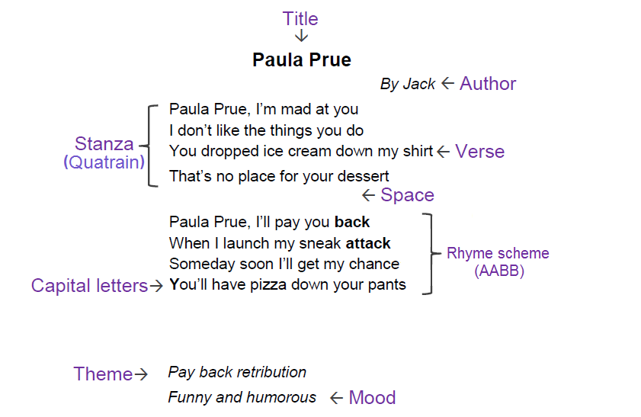

Isabelle.Rhalab@ac-poitiers.fr

Title
​The name of the poem.

Author/Poet
A person who writes poems. They usually leave their signature.
Stanza
(Une strophe)
A fixed number of lines of verse forming a unit of a poem.
Names for stanzas:
- Couplet (2 lines).
- Tercet (3 lines).
- Quatrain (4 lines).
Space
​
A gap between stanzas.

Verse
A single line in a poem. It gives a structure to poetry form.
​
​
Rhyme
Words that end with similar sounds; usually at the end of a line. Rhyme is principally a function of sound rather than spelling.
For example : words rhyme that end with the same vowel sound but have different spellings: right, kite,and height.
Here are some types of rhyme:
- Perfect rhyme – The ending sound of each word matches exactly: soap and hope.
- Rich rhyme – It involves words that are pronounced the same but are not spelled alike and have different meanings: break and brake.
- Eye rhyme – Two words that look similar on a page, but do not actually rhyme in spoken pronunciation: move and love.
Rhyme scheme
The pattern of rhymes at the end of each verse or line in poetry. ​
Here are some types of rhyme scheme :
- Alternate rhyme: It follows the pattern ABAB.
- Coupled rhyme: The rhymes occur in pairs, such as AABB.
- Enclosed rhyme: The pattern is ABBA, in which A encloses the B.
Isabelle.Rhalab@ac-poitiers.fr

Part 2 What about Sara Coleridge ‘s poem ?

1. Read carefully the following poem.

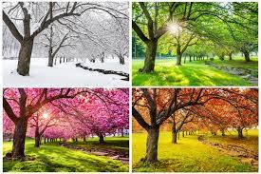

January is the first month in the year

by Sara Coleridge (1802 – 1852)

1
January is the first month in the year
When the weather is cold and clear:
Boys roll the snowball round and round
Or slide on the pond where the ice is sound.
2
February Fill-ditch then sets in
With a pelting rain that will wet you to the skin
Soon as the sky shews a speck of blue
How the pretty snowdrops gleam to view.
3
March comes on with wind from the East,
A wind good neither for man nor beast:
The daffodil flaunts it in yellow and green
What cares she if the wind be keen?
4
April’s showers and sunshine bright
Paint the rainbow to our sight:
Then the violet smelling sweet
Under every hedge we meet.
5
May hangs blossoms on the thorn —
Then the lamb and colt are born:
Primroses forsaken die
Gaudier flowers engage the eye.
6
June with tulips, eglantine
Will be finest of the fine:
Rose and lily odours yield
New-made hay scents many a field.
7
In July the sultry night
Scarce will cool the weary wight:
Then the woolly sheep are shorn
Then the harvest home is borne.
8
August brings the juicy grape
Melons too of goodly shape:
Then the melting peaches come
Nectarine apple pear and plum.
9
In September hares must die
Grouse and partridge swift and shy:
Then’s the time to hunt and shoot
Then’s the time to gather fruit.
10
In October drink good ale
Soon the year begins to fail:
Drink the ale so fine and mellow
Though the leaves are turning yellow.
11
Chill November’s surly blast
Tears the boughs and drives them fast:
Then the sleet mixed up with rain
Makes us of the wet complain.
12
Cold December’s frosty air
Makes us to the fire repair:
Then good friends each other meet
To enjoy a Christmas treat.

Isabelle.Rhalab@ac-poitiers.fr

1. Answer the following questions in complete sentences. You can of course use the previous lesson as a guide.

1.1 Who was Sara Coleridge. Answer briefly using the Internet.
1.2 What is this poem about ?
1.3 What is special about it ?
1.4 What about you ? What is your favourite month or season ?
{ Les élève vont pouvoir travailler en binôme ou individuellement. A chacun est attribuée une strophe du poème de Sara Coleridge qu’ils auront à traduire.
Enrichissement lexical : A l’aide du vocabulaire relevé, ils complèteront le tableau fait à la maison ( voir *** Homework ci –dessus Step 2) }
Other useful vocabulary :
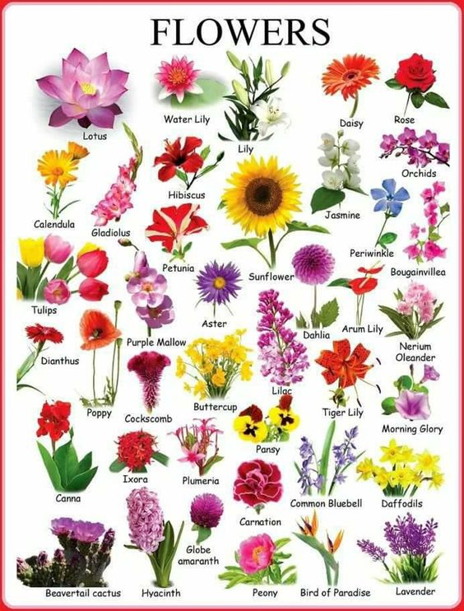

2. Homework : Travaillez la prononciation sur le site donné en classe.

Isabelle.Rhalab@ac-poitiers.fr

