SEQUENCE 3 PM – Write a poem ? Of course I can !

Step 2
___________________________________________________________________

- EOC : Learn a short paragraph, recite it with correct intonation and pronunciation.
- CO : Comprendre une vidéo, apprendre / réviser ses acquis.

- Travailler la méthodologie : « 3 listenings / 3 colours ».
___________________________________________________________________

Part 1. What’s the weather like in …?

a) Read the following paragraphs. Choose one , write the towns on your map and draw the corresponding picture.
2.
1. In Glasgow, it’s snowy.
In Manchester, it’s cloudy. In Belfast , it’s foggy.
In Belfast,it’s sunny. In London, it’s sunny.
In Cardiff, it’s foggy. In Manchester , it’s rainy.
In Belfast , it’s hot. In Cardiff, it’s hot.
In Glasgow, it’s cold. In Newcastle, it’s cold.
In London, it’s windy.

3. 4.
In London, it’s windy. In Belfast , it’s snowy.
In Belfast, it’s cold. In Glasgow, it’s foggy.
In Manchester, it’s sunny. In London, it’s rainy.
In Cardiff, it’s rainy. In Manchester, it’s sunny.
In Glasgow, it’s cloudy. In Cardiff, it’s hot.
In Newcastle, it’s snowy. In Liverpool, it’s cold.

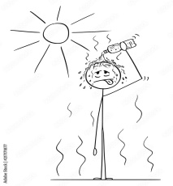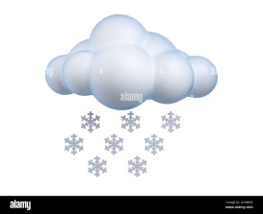

b) Learn by heart this paragraph and recite it to the class for next week.

Isabelle.Rhalab@ac-poitiers.fr

Part 2 : CO – What’s the weather like ?

https://www.youtube.com/watch?v=kx3LgQ4KT-I&ab_channel=Apprendrel%27anglaisaveclesTutosdeHuito

1. You are going to watch a video three times. On your rough paper, write down everything you understand.

- Method: to help you, change colour each time you listen. This will help you identify what you have understood and already written down.
- 1st listening in blue
- 2nd listening you complete in green
- 3rd listening you complete in red

2. Briefly sum up in a few lines in French, what this document is about. Who, what about?
………………………………………………………………………………………………………………………………………………………………………………………………………………………………………………………………………………………………………………………………………………………………………………………………………………………………………………………………………………………………………………………………………………………………
- { NB : Les exercices suivants peuvent être faits tout ou partie en évaluation, en laboratoire de langue. }
3. Answer the following questions ticking the good answer . Then fill the text.
- Subject of the document = How to speak about O the breath
O the wave
O the weather
- What is the weather like ? Give 2 other expressions :

a) …………………………………………………………………………

b) …………………………………………………………………………

- What does “overcast” mean (signifie) ? It is ……………………………….. and ………………………………………. .
So you can’t ………………………………………………….
- Do you know what drizzle is ? It’s raining very lightly ; it is a very ……………… ………………………….. .
So your clothes are …………………. . ……………….. is a little …………. .
- A mild temperature = ……………………………. , ……………………………. either.
- What is this ? It is ……………………………………..

It is very useful ( utile) when …………………………………… Isabelle.Rhalab@ac-poitiers.fr

- Now the wind picks up ! That means that the wind .……………………………....
………………………………………… . Your ……………………………….. is totally useless (= useful ).

After a phone call :

His friend told him it should clear up this afternoon = …………………………….
…………………………………………………………………………………………..

Now, imagine we are in …………………………….. (season). It is a bit ……………………………., a little …………………………………… . it is not comfortable.

So you need a …………………………………………….. to go out.

- When the weather is freezing = freezing means really …………………., you can see your breath.

- So you must ………………………………… with a ……………., a ……………

and a ………….. …………………. Before you ………………………… .

Finally, he prefers ……………………………………………………………………..

He really likes ………………………………………………………….. and ………

……………………………………………………………………………..

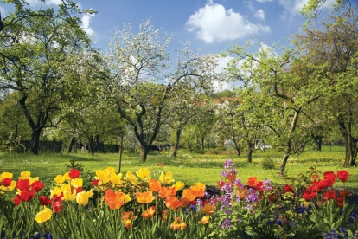

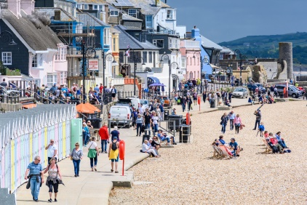

***Homework : Relevez le vocabulaire inconnu, apprenez –le. Créer 4 groupes (1 par saison) et identifiez le vocabulaire pour chacun ( Ex : Winter : frozen, cold, snow …)
Isabelle.Rhalab@ac-poitiers.fr

