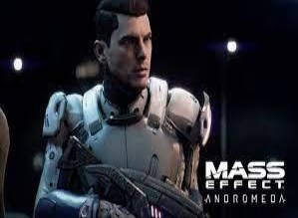
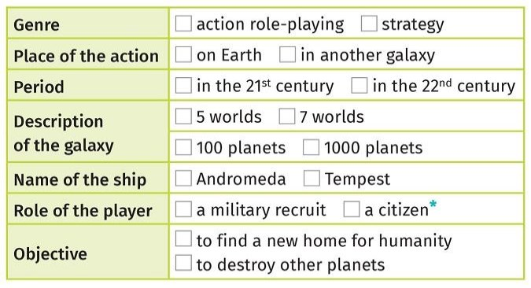
Part 1: Ready Player One ?

Je suis capable de comprendre l’essentiel de la bande-annonce d’un jeu vidéo. (A2-A2+)

→ Listen to the document to complete the exercises:

→ Use the elements to present Mass E ect Andromeda orally:a) __________ is an __________ video game.
b) The action takes place __________, ___________ .
c) In the galaxy, there are __________ and __________ .d) The name of the ship is ____________ .
e) The player has the role of ____________ .f) His objective is _________ .
____________________________________________________

→ After completing the labels, say what there is or there are, in each video game:

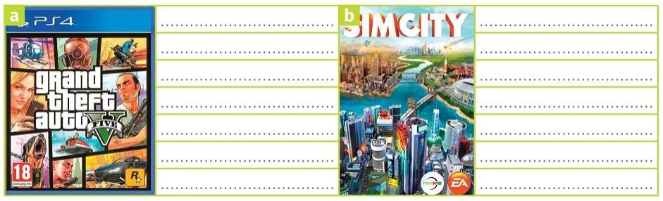
schools-islands-a desert-valleys-hospitals-beaches-ﬁre stations-lakes-a forest- apartmentbuildings-shops-o ces-hills-farms

For ne t i : _____/_____/_____

1 - P r e p a r e t h e ﬁ r s t s t e p o f t h e m i s s i o n .
2 - R e a d t h e d o c u m e n t e n t i t l e d “ H o w t o u s e p ron o u n s i n E n g l i s h ? ”→ Step 1:

Je suis capable de rédiger une brève description d’un jeu vidéo:

Utiliser les éléments suivants pour écrire un court paragraphe de 5 lignes pour décrire lejeu vidéo The Witcher 3.

● Genre = action role-playing
● Setting = a fantasy world - di erent regions- mountains, forests, castles
● Main character = Geralt of Rivia, called “The Witcher”, who is a monster hunter● Secondary characters = humans, nonhumans, elves, monsters
● Objective = ﬁnd the emperor’s daughter

___________________________________________________________________________________________________________________________________________________________________
How to use pronouns in English ?

P r o n o m s p e rs o n n e ls ( s u je t = quip i l o te n t l a p h ra se )
P ro n o m s pe rso n n e ls (c o m plém en t= qui co m plè ten t l a ph r as e)

- Je = I
- Tu / Vous = You- Il = He
- Elle = She
- Il/Elle neutre (animal, objet) = It- Nous = We
- Ils/Elles = They
- Me/ Moi = Me
- Te / Toi / Vous = You
- Se / Soi (masculin)= Him- Se/ Soi (féminin)= Her
- Se / Soi( neutre) = It- Nous = Us
- Leur = Them

P r o n o m s p o s s e ss if s ( = p o u r
i n d i q u e r à q u i a p p a rt i e n t l 'o b jet )
Ad jec tif s po ss es sif s (= p o ur
re mpl ace r l ’o b j et et le p o ss ess eur)

- mon/ma/mes = my
- ton/ta/tes/ votre/ vos =your- son/sa/ses à lui = his
- son/sa/ses à elle = her- son/sa/ses neutre = its- nos/nôtres = our
- leur/leurs = their
- mien/mienne = mine
- tien/tienne/vôtre/ vôtres = yours- sien/sienne à lui = his
- sien/sienne à elle = hers- sien/sienne neutre = its- nôtre/ nôtres = ours
- leur/ leurs = theirs

