Step 4
Meatballs and pasta
Here is a recipe of the Ministry of Food. Watch the video https://www.youtube.com/watch?v=FWWHtN6wDvw and find the following information:
- Name of the recipe: _____________________________________________________

- Very easy - Easy – difficult?

- Time: _____________________________________________________________

- Ingredients and quantities: choose among the following ingredients; cut them out and put them in the grid. Give the name and the quantity of the ingredient. (exercise à réaliser avec les tablettes sur l’application Etigliss)

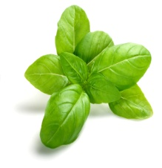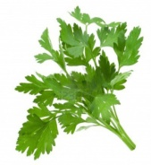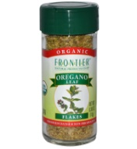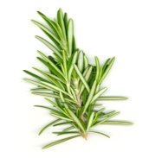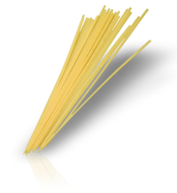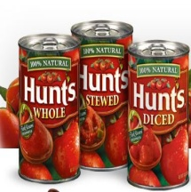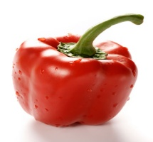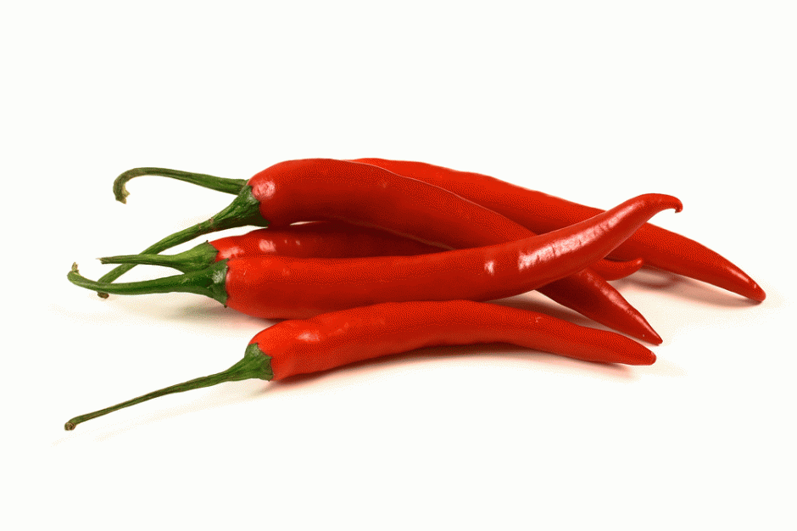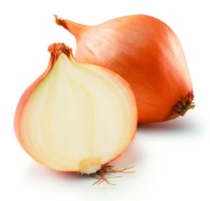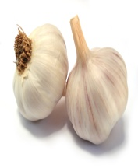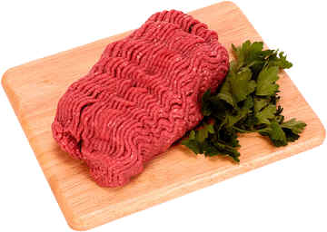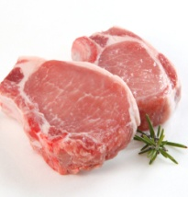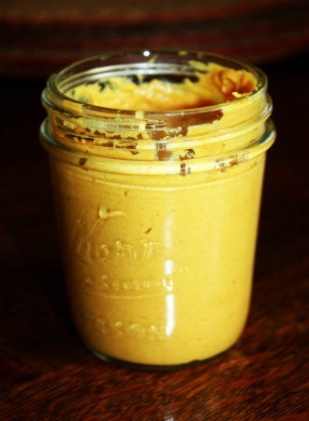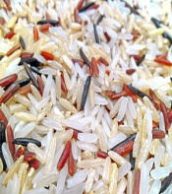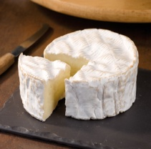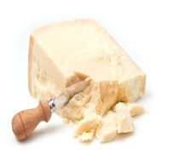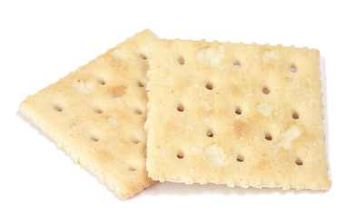

Picture | Ingredients | Quantity

- Utensils:
_________________________________________________________________________
_________________________________________________________________________
_________________________________________________________________________

- Different steps: put the steps in the right order
The right order | The steps
1.  2.  3.  4.  5.  6.  7.  8.  9.  10. | - Put the pasta and meatballs in a dish  -Drain the pasta  -Make the balls  -Cook the balls for 8 minutes  -Put the pasta in the pan  -Mix the meat, oregano, mustard, an egg, rosemary and breadcrumbs in a bowl.  -Fry chili and garlic in olive oil in a pan.  -Cook the spaghetti for 12 minutes in boiling water.  -Put the meatballs in the tomato sauce  -Add the basil and two tins of tomatoes

