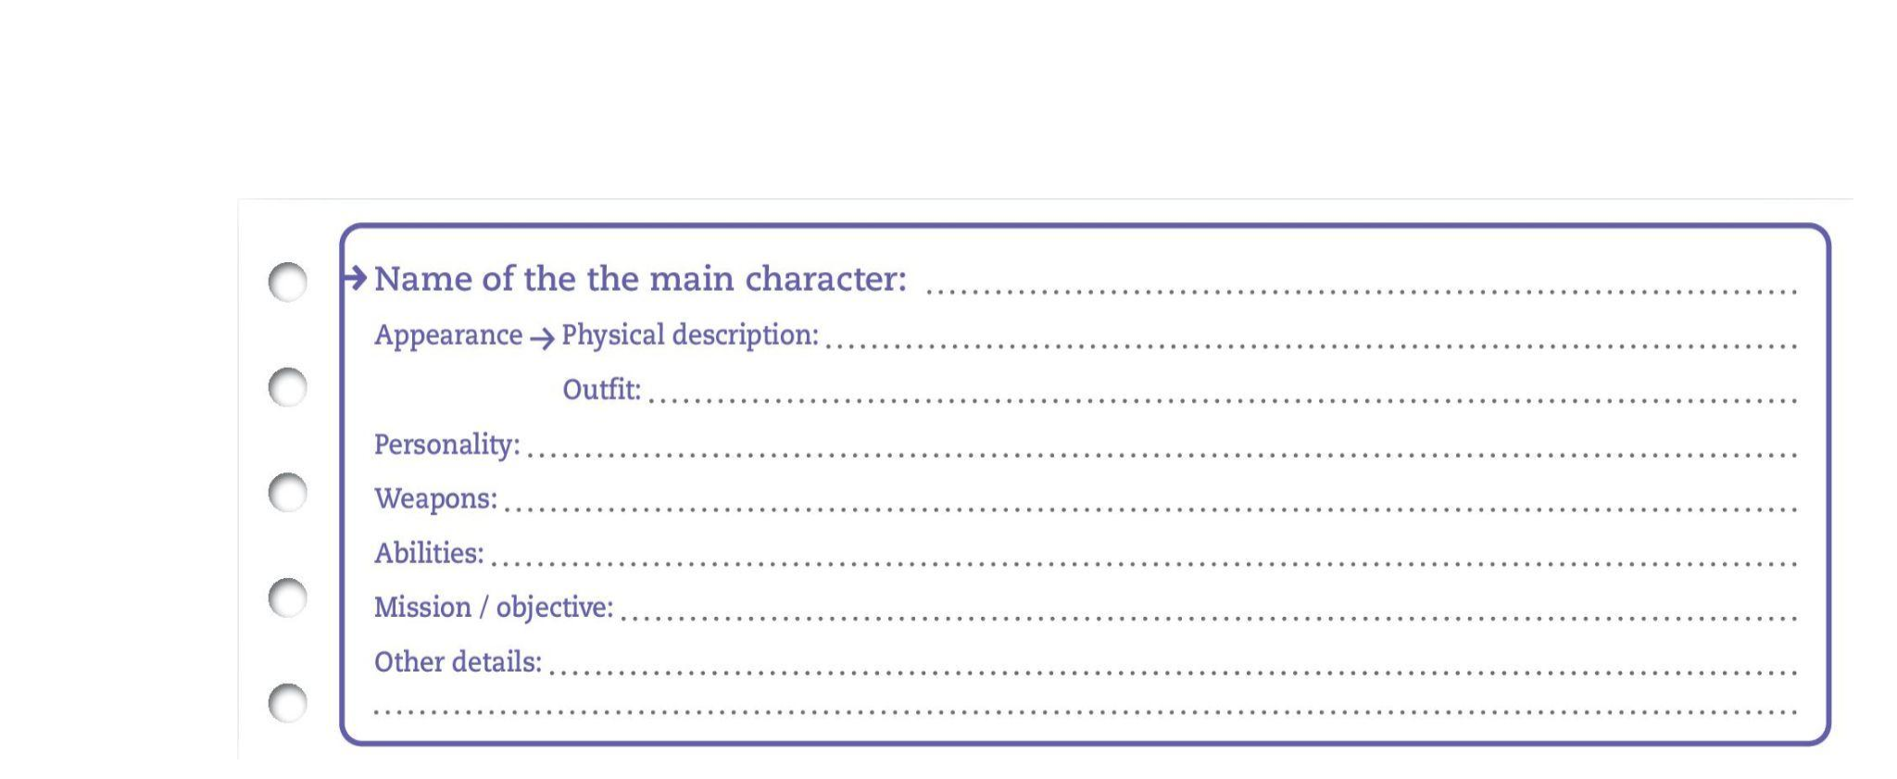
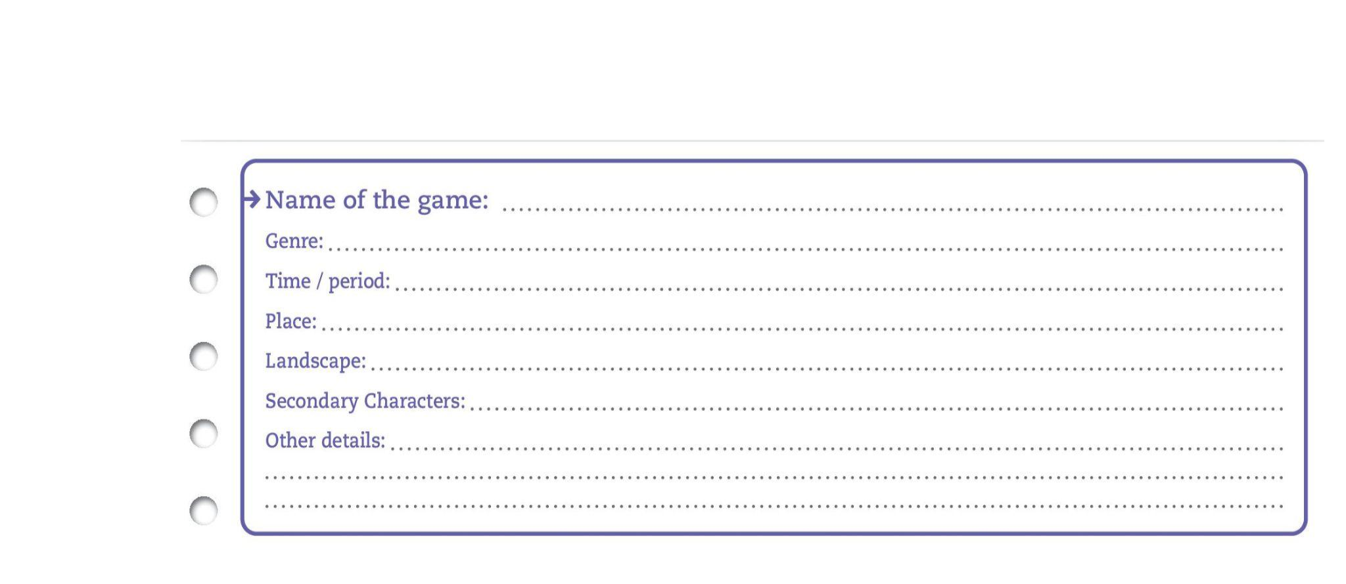
MISSION

→ Describe the place and the main character of your favourite video game :

→ Prepare a brief oral presentation following the advice below:

- Train to say di cult words or expressions;

- Check how to say a word if you don’t know it;

- Present the video game or the main character to the class, with some pictures;- Tell the reasons for your choice (justify).

