ÉVALUATION SPÉCIFIQUE POUR L’ATTRIBUTION
DE LA MENTION « SECTION EUROPÉENNE »

Baccalauréat professionnel
Assistance à la Gestion des Organisations et de leurs Activités

Session 2024

Épreuve orale
Durée de l’épreuve A et B : 20 minutes
Préparation : 20 minutes
A. Première partie : durée 10 mn, préparation : 20 mn

SUJET N° 1
Document candidat

BREAK ROOM

Travail à faire par le candidat

You have been working for one year as a Human Resources coordinator at the WAT company’s headquarters. There are 41 employees working there. All the buildings are from the 90's. The coffee room is 6 meters long and 5 meters wide. The walls are beige and the furniture is mostly grey. Next to it is an unused office (9m * 6m). Your manager is Roger Antcliff, head of Human Resources. He has asked you to improve the employees’ well-being at work. In order to guide your decisions, a survey has been conducted. You have just received the results (doc 1). Using these results and the other documents provided (doc 2 and 3), you have been asked to come up with a proposal to improve the working conditions. Your maximum budget is £12,000.

Role play :
- You are the human resources coordinator.
- One of the teachers is your manager, Roger Antcliff and the other is Nelly Simonds, Chief Financial Officer.

You are expected to :
- Prepare a proposal to improve WAT’s break room. You’ll make sure to base your decision on hard facts so you can discuss it with your managers.
- Present your proposal to Mr Antcliff and Mrs Simonds.

Enclosure(s):
- Document 1 : Employees’ satisfaction survey
- Document 2 : 5 ways to create a relaxing space to boost productivity | Truspace
- Document 3 : A selection from huntsoffice.com.uk, an office furniture provider
- Appendix : Discussion framework
Document 1 : Employees’ satisfaction survey
- Do you think our break room is welcoming ? 79 % NO
- Do you think our work environment is relaxing ? 85 % NO
- Would a new and bigger break room make you feel better at work ? 95 % YES
- How would you imagine a nicer relaxing area ?
- Colourful 72 %
- Comfortable with modern chairs 80 %
- A real kitchen 66 %
- A huge table to chat during lunch time 70 %

Document 2 : 5 Ways To Create A Relaxing Space To Boost Productivity | Truspace
So how do you present an office space that looks like a home, but allows your employees to be relaxed but productive ?
- Bringing the feeling of home to your work
You could add sofas, plants, fabrics, and more organic materials like wood furnishings into previously glass-filled rooms, as an office should be warm and welcoming.
- Allow efficiency through flexibility
At home, we move around and use the space that is available. At work, this can also be done, and if the employees have the freedom to move around, positive results may follow.
- Update the office kitchen
Adding a communal table and upgrading the space to include a fully functional kitchen, you will increase communication and allow workers to get to know each other.
- Introduce a relaxing space
It may be a wise idea to create a breakout space that allows employees to relax before getting back to work again.
- Bring some fun
You could add some art, a ping pong table, a dartboard, or other fun fixtures that will allow workers to take their mind off of work and get to know each other better.
Document 3 : A selection from huntsoffice.com.uk, an office furniture provider
Stools
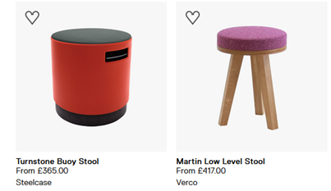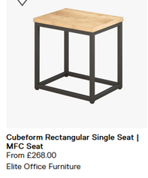

Lounge chairs
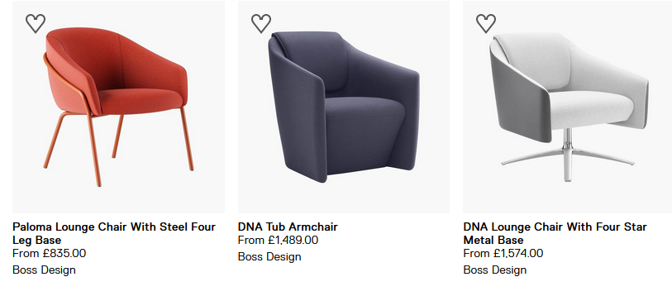
Wall Art
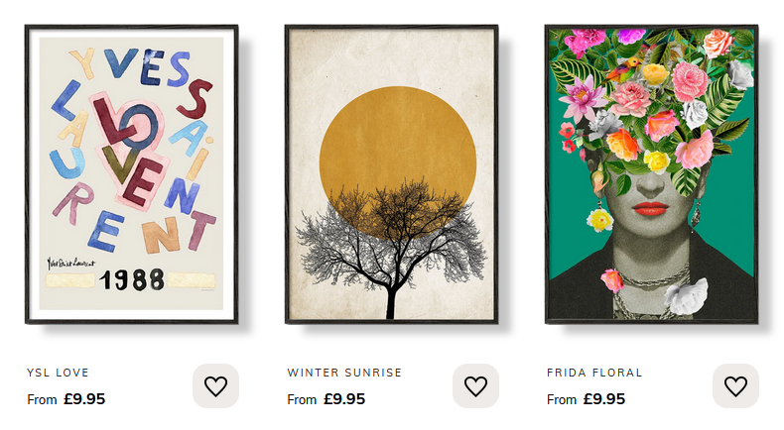
Rugs / carpets

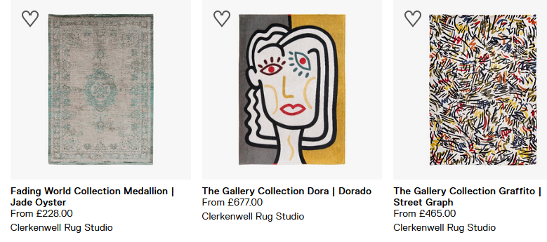

Tables

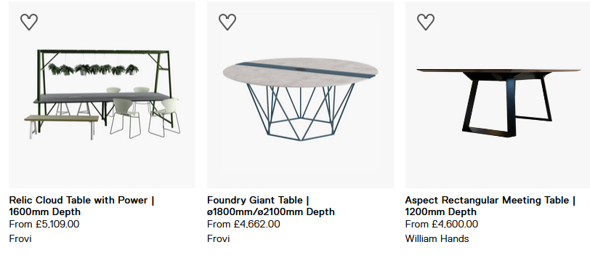
Appendix : Discussion Framework

Greet your managers
Clarify the meeting objectives
Explain why a new room is needed
Detail your proposal
Justify and defend your proposal
Provide an estimate of the budget
Take leave

