Charlie and the photo competition

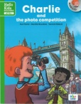 | Monument | Underground station
First, they go to | ----------------------------------------- | ----------------------------------------
Second, they go to | ------------------------------------------ | ----------------------------------------
Third, they go to | ------------------------------------------ | ----------------------------------------

