In my schoolbag, I’ve got…

1) Listen and number the school things

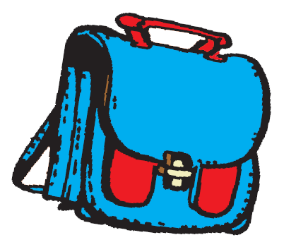 |  | 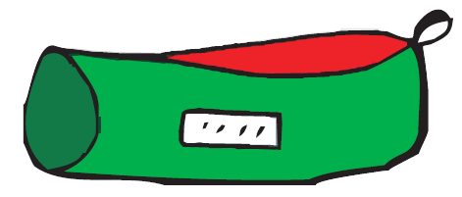 | 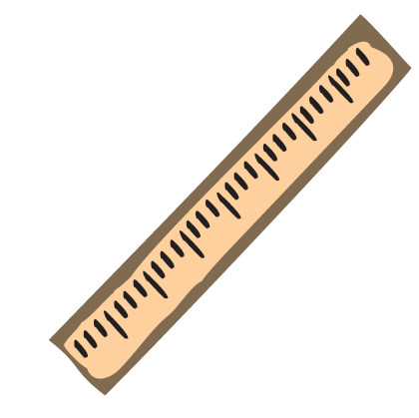 | 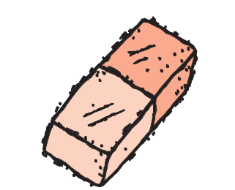 | 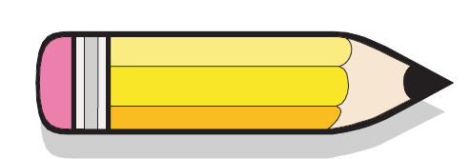 | 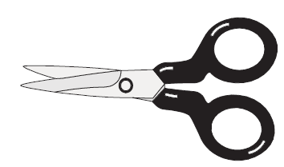 |  | 

2) Match the word with the object
a glue  a ruler  a book  a pen | 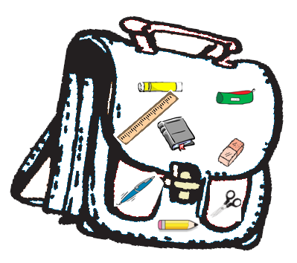 | a pencil case  a rubber  scissors  a pencil

2) Write in the right order
schoolbag / In / I’ve / green / got / pencil / my / a

In my schoolbag, I’ve got…

1) Listen and number the school things

2) Match the word with the object
a glue  a ruler  a book  a pen |  | a pencil case  a rubber  scissors  a pencil

2) Write in the right order
schoolbag / In / I’ve / green / got / pencil / my / a

