DOSSIER ICONOGRAPHIQUE DU DOSSIER HIDA
« Casimir Malevitch : une icône de l’art russe du XX ème siècle »
Ateure Hélène Eftimakis
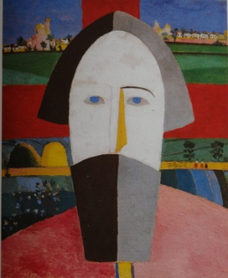
http://fototeine.wikispaces.com/file/view/26.Kazimir_Malevich%2C_Talupja_pea.jpg
http://en.wikipedia.org/wiki/Suprematism
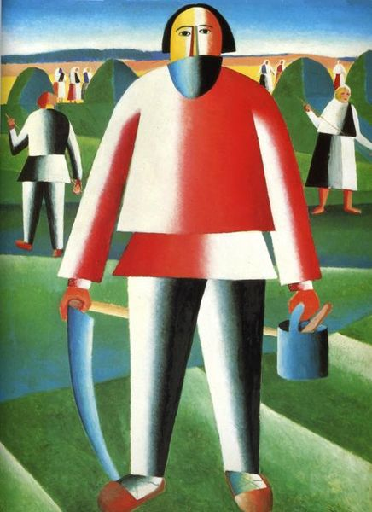
http://www.wikipaintings.org/en/kazimir-malevich/haymaking-1929
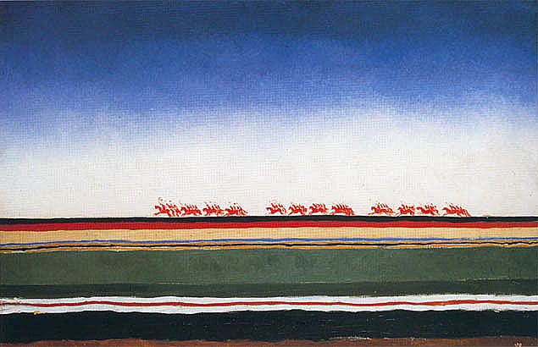
http://www.wikipaintings.org/en/kazimir-malevich/red-cavalry-1932

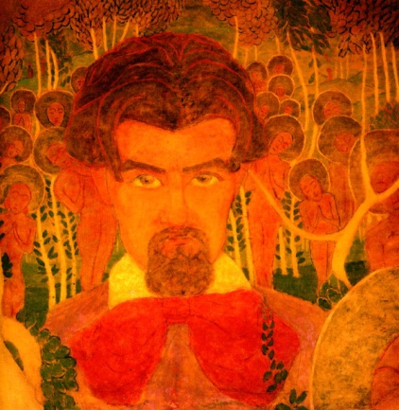
http://www.wikipaintings.org/en/kazimir-malevich/self-portrait-1907
Kazimir Malevich self-portrait1907: tempera cardboard 69 x 70 cm
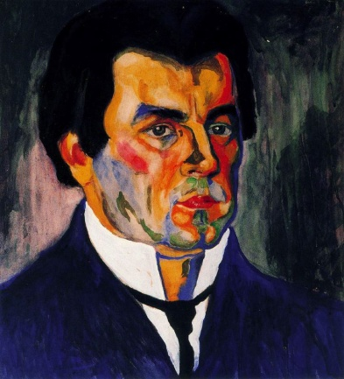
http://www.wikipaintings.org/en/kazimir-malevich/self-portrait
Kazimir Malevich 1911gouache, watercolor paper46.2 x 41.3 cm: Russian Museum, St. Petersburg, Russia
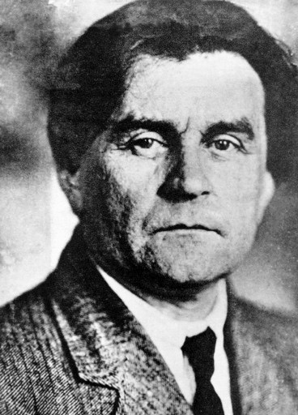
http://fr.wikipedia.org/wiki/Kasimir_Malevitch
auteur inconnu. Photo de Malévitch prise avant 1935

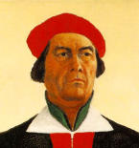
Malevitch. “Autoportrait « . détail. 1933
http://en.wikipedia.org/wiki/Kazimir_Malevich
http://en.wikipedia.org/wiki/Suprematism

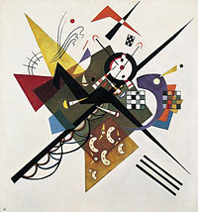
http://en.wikipedia.org/wiki/Wassily_Kandinsky

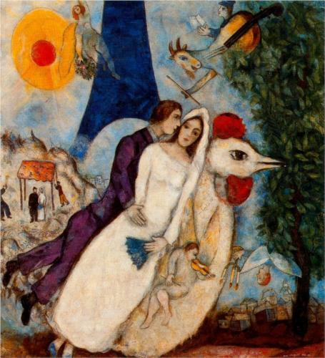
http://www.wikipaintings.org/en/marc-chagall/the-betrothed-and-eiffel-tower-1913

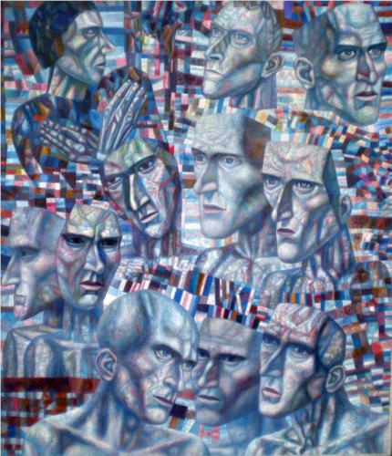
http://www.wikipaintings.org/en/pavel-filonov/shostakovich-s-first-symphony-1935
Pavel Filonov. Shostakovich's First Symphony 1935oil68 x 99.8 cm Tretyakov Gallery, Moscow, Russia

Bibliographie
Andrei Nakov “Malévitch : Aux avant-gardes de l'art modern” 2003. Ed "Découvertes" Gallimard
http://www.larousse.fr/encyclopedie/peinture/Mal%C3%A9vitch/153282

http://mediation.centrepompidou.fr/education/ressources/ENS-abstrait/ENS-abstrait.html

