Pictures | English name  (French name) | It’s used to
Beaker
(……………)
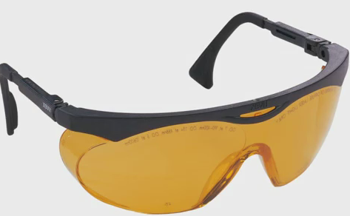 | ………………..  (……………)
Bunsen
Burner
-
Flame
(Bec bunsen)
Tripod (Stand)
(…………………)

Pictures | English name  (French name) | It’s used to
Erlenmeyer Flask
(………………..)
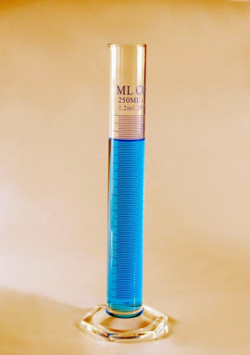
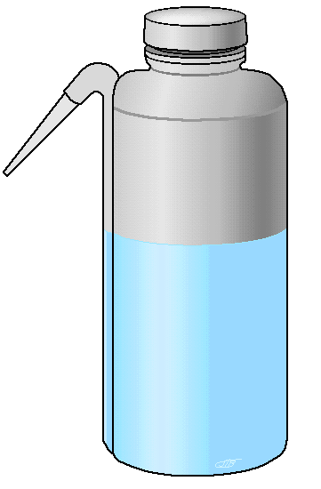
……………….
(Entonnoir)
Florence flask
-
Round Flat-Bottom Flasks
(……………………)

Pictures | English name  (French name) | It’s used to
Burette holder
+
burette
+
Support stand

(.............
………….
………….)
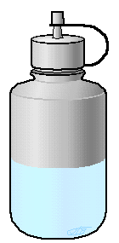
………………..
(Fiole jaugée)
 | ……………  (……………..) | take small quantities of solid chemicals
Pictures | English name  (French name) |  | It’s used to
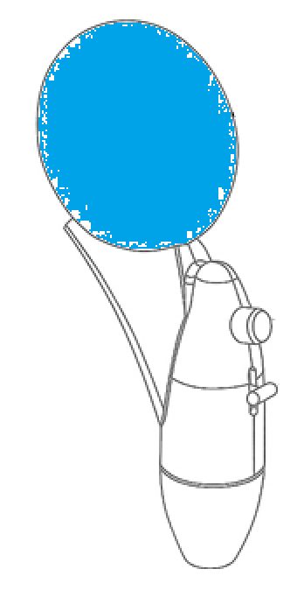 | ……………  (………….  …………)
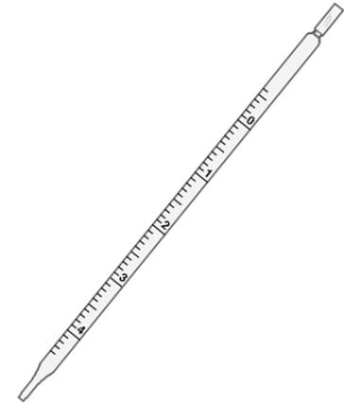 | …………..  (………..  ………….)
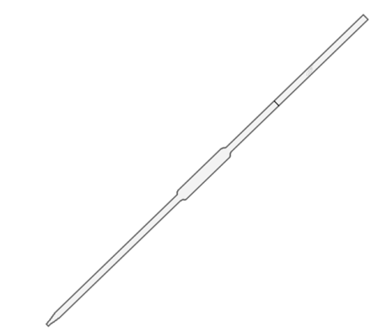 | …………….  (………..  …………….)
……………..

(…………
…………..)
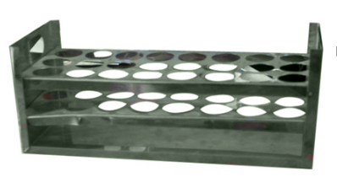 | …………  ………..  (………..  ……………)

Pictures | English name  (French name) | It’s used to
………….
…………..
(…………
……………)
…………………
(Fiole à vide)
………….
…………
…………..
(pilon et mortier)
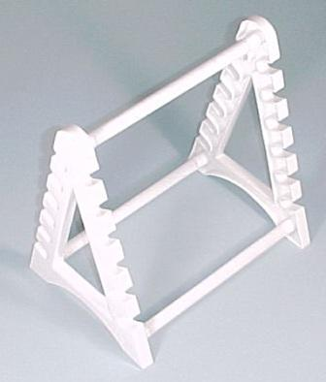 | ……………..  (……………  ……………..)
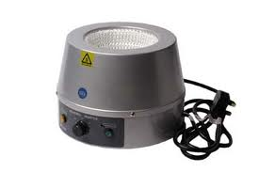 | ………………..  (…………….)

Pictures | English name  (French name) | It’s used to
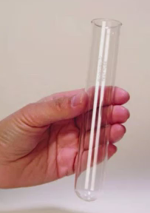 | ……………  (……………….)
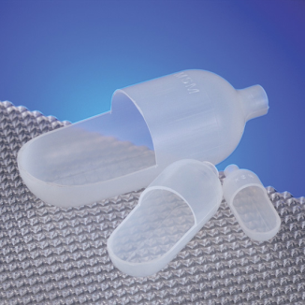 | ……………………  (………………….) | weigh solid samples
    

