SEANCES d’AP : Préparer mon stage de 5 semaines à Plymouth
POUR LE PROJET ERASMUS : la préparation pratique, culturelle et linguistique se fait sur des heures D’AP (accompagnement personnalisé) pour les élèves sélectionnés pour partir.
Voici une des fiches donnée aux élèves pour cette préparation :
Domaines : Agir au quotidien à l’étranger + Travailler à l’étranger

WORKSHEET 1 :
- Preparing your way from Poitiers to Plymouth: fill in the grid

From: | To: | Time: | Means of transport

- How “Not to be lost in the London Underground”
- How to use my Oyster card: explain it orally

- If you are lost what are the questions you can ask?
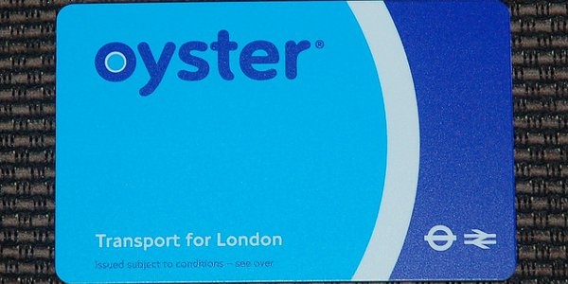
- Studying the tube’s map before: I will have to take it from…………………………………..to………………………………..
- Find your way on the map:
http://www.londresweb.com/plan_metro_londres.htm

4 – In Plymouth:
- In Plymouth I will be in contact with my referent : Gabriele Bogart from our partner school : TELLUS PLUS and with the teacher responsible of this European Project from my vocational school Marc Godrie : Auger Karine.

- Go and see our partner school on the net
https://plus.google.com/+MeridianEnglishTellusGroup
- Find : what can you do at night at the school with the other students from all over the world?

- Find a map of Plymouth and situate the school.

- Use the buses times and maps ( given by the teacher) to answer the following questions:

- How can I go from my host family to the school?

- Could you tell the way from your home to your place of work? 5-What should I visit in Plymouth:
http://www.plymouth.gov.uk/homepage/leisureandtourism/tourismandvisitors/touristinformationcentre.htm
- Listen to the testimonies of my friends who have already been to Plymouth and take notes: (des élèves de terminales témoignent auprès des élèves de premières une fois sélectionnés mais aussi dans tout l’établissement auprès par exemple des secondes, un film est aussi en train d’être tourné sur tous ces témoignages des différents pays par l’animateur culturel et les services civiques)

- Answer the following question about Plymouth ( + exploitation du film sur Plymouth sur le site TV) :

-1- Where is Plymouth located In England? In which Region?

-2- How many inhabitants are there?

-3- What is the name of the harbor and where is it on the map?

-4- Why is the harbor so important? What happened here?

-5- What is the Mayflower?

-6- Is there a University in Plymouth and where is it?

-7- Which places of interests can you visit?

-8- Who was M. Drake?

-9- Are there many restaurants in Plymouth and what are their specialties’?

-10- Are there some famous events or festivals in this city?

