A GOOD MIX ? !

Grade: Term.BP MELEC |  |  | Subject: | Money, Fame and |  |  |  | Date: | Sept. 4th--
 |  |  |  |  | Sporting passion
 |  |  |  |  |  |  |  |  | Sept.15th
Task: | Discuss the sentence: “ athletes |  |  |  |  | Lesson: |  |  | / 100
 | make too much money !”

Lesson Goals:

In France we’ll be welcoming 2 major sporting events within 2 years. Records and fair play will be celebrated but there are two sides to the coin... Money and fame will also be criticized.

Tools Needed:

Sport vocabulary and phrases Linking words and expressing opinion

Numbers and currencies

0

Structure / Activity:

LESSON 1: ENTERING SPORTING

WORLD

describe and discuss a picture ;

create a class mind map about sport;

play with words

Learning Objectives:
  - With a partner, draw the portrait of a sportsperson

    - Present this person and justify your choice

- Give your opinion about your mates’ sportsperson

LESSON 2: SPORT MARKETING listen to a document about this topic; understand a text about bookmakers;

write a 10 line-text about your vision of fame

and money in this sector

LESSON 3: WHAT’S TO BE A FAMOUS SPORTSPERSON ?

Learn about Myron ROLLE;

Present your sportsperson;

Give your opinion.

Assessment: | YOUR presentation of a sporstperson: 40 points
 | Personal opinion about the quotation: 15 points
 | Sum up of a video: 30 points
 | Understand a text: 15 points

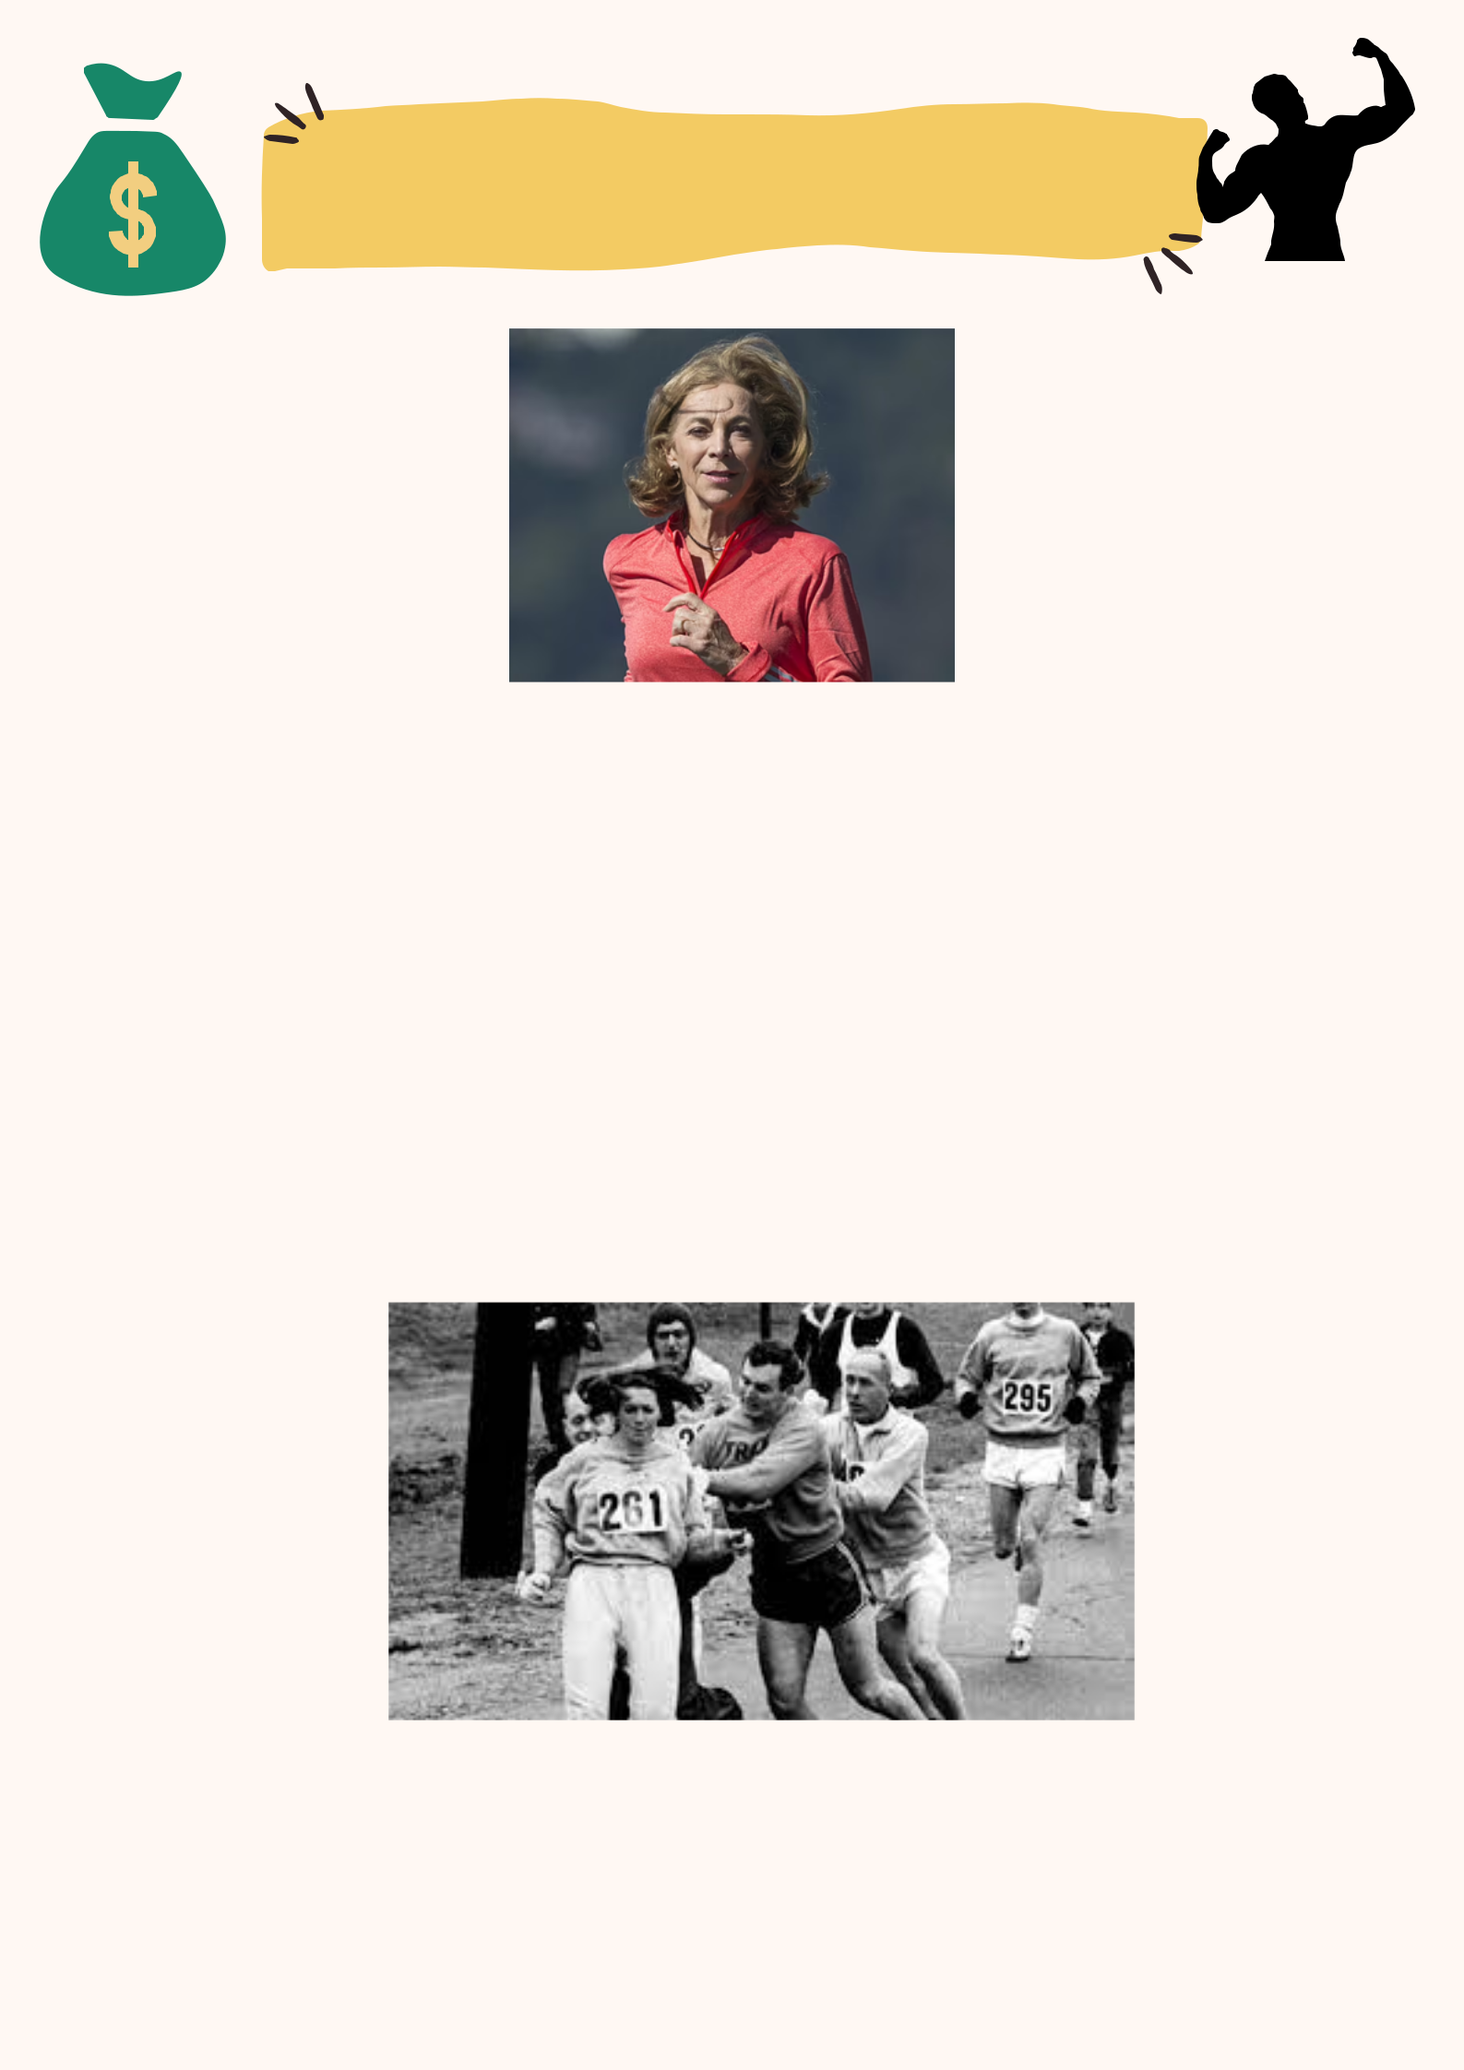
THE PERSON I ADMIRE

IS

Kathrine SWITZER. She is 70 and she keeps on running.

0

Back in 1967. That year, she became an icon.

0

Wearing number 261 and some lipstick, she enrolled in the Boston Marathon under

the initials «K.V. Switzer, Syracuse», on April 19th. She finished it within 4h 20

minutes !

0

An incident on the sixth kilometre changed her life. A journalist, posted on a news truck, yelled that a woman was running. Jock Semple, the organizer, said to her: «Get out of my race, and give me these numbers!». He tried to snatch her bib but she resisted. Her boyfriend, who was running beside her, pushed Jock Semple away with a sudden shoulder kick. The 20-year-old crossed the finish line but she was disqualified and banned from the American Athletics Federation.

As a journalist,a businesswoman and an activist, she has never stopped fighting, worldwide, for gender equality and the recognition of women in running. She broke down male monopolies. She created an international women’s circuit and organized 400 women’s races in 27 countries. She ran over 40 marathons. I admire her for her strength and tenacity and thanks to her, the first women’s marathon at the 1984 Los Angeles Olympics was organized !

