Step 4. My sweet home and favourite place, I would love to live in.
___________________________________________________________________

- 1. CE : Floating house – Comprendre un texte – Niveau B1.

- 2. a) Travail individuel : Description d’un plan de maison.
b) EE : Rédiger un paragraphe argumenté sur l’agencement des pièces dans votre maison.

- 3. a) EOI : Description d’une pièce – Work in pairs.
b) EE : Rédiger un paragraphe argumenté sur votre pièce / endroit préféré.e.
___________________________________________________________________________
- 1. CE : Comprendre une autre idée de construction – S’adapter au changement climatique.
Floating houses
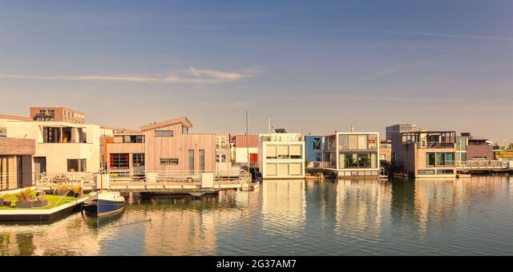 Alamy 2G37AM7
Ever thought of buying a house you could move with you ?
Recognizing the growing scarcity* of building ground in the Netherlands, a Dutch construction company has started building houses on water. The houses, made of wood and lightweight aluminium, are linked to each other by walkways but can be detached from the surrounding neighbourhood and individually moved by tugboats*.
The company Ooms Bouwmaatschappij has built the first eight of the planned 500 floating houses on the outskirts* of Amsterdam, capital of the world’s third most densely populated country. The houses are designed to withstand gales* and can be located up to 100 metres from the shore.
For centuries, the Netherlands has fought against invading water (…). But the philosophy is changing in the wake of* global warming, blamed for the 20 cm-rise in sea-level over the last century. Instead of driving out the water, the Dutch is trying to live on it.
And since we are getting more and more rain, we are having more and more water in this country which is fifty percent below the sea level as you know, and so we have developed this concept of building villages on the water, Ooms Bouwmaatschappij marketing director, Gijsbert van der Woerdt told Reuters.
https://www.reuters.com
some help : scarcity = rareté withstand gales : resister aux tempêtes
tugboats = remorqueurs outskirts = périphérie in the wake of = à la suite de
Isabelle.Rhalab@ac-poitiers.fr

- Read this article carefully and answer the following questions.

1. Where does it happen ?
2. What is the problem raised in this article ?
3. What solution is proposed ?
4. What are the houses made of ? Why ?
5. What are the specific construction features of these houses ?
6. Summarise this article in French in a few lines
7. Would you like to have such a house ? Why ? Why not ?
8. What would yours be like ? Floors ? Number of rooms ? Living space ?

- 2. a. Travail individuel : Description d’un plan de maison.

a-1) Connect the following prepositions.

à gauche o o under
à côté de o o opposite
en face de o o in the middle of
au-dessus de o o above
à droite de o o in front of
au milieu de o o below
sous o o on the left
au fond de o o at the bottom of
en-dessous de o o next to
devant o o on the right

Isabelle.Rhalab@ac-poitiers.fr

a-2. Describe orally and individually this house plan.

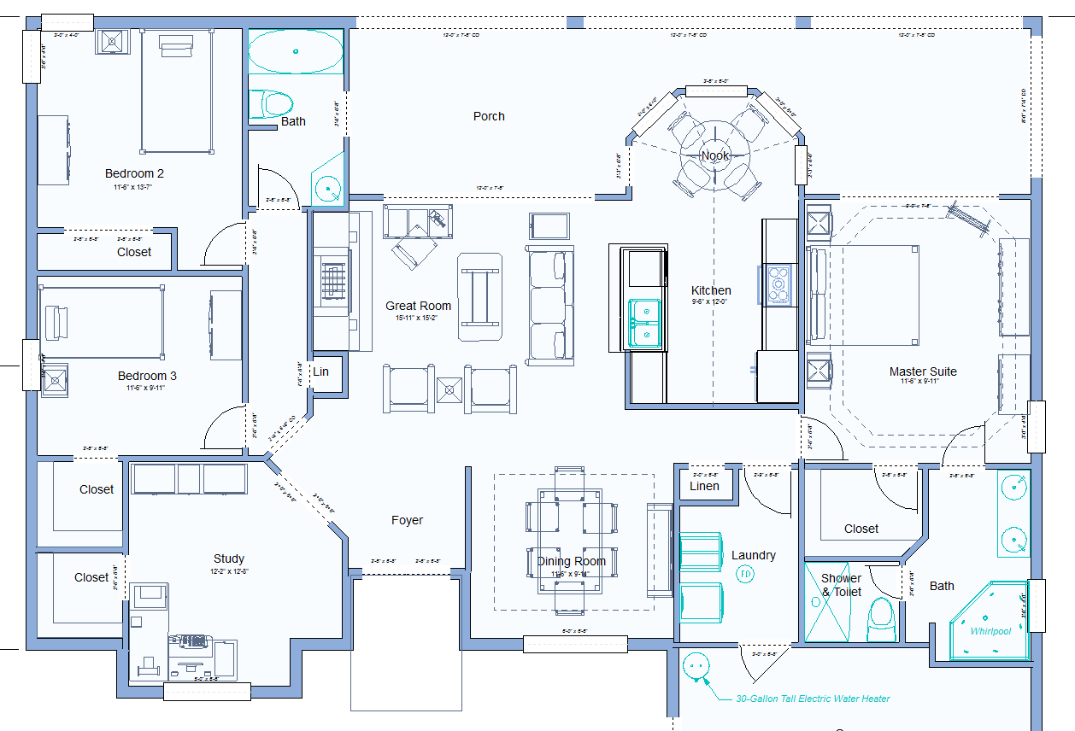
https://www.punchsoftware.com/blog/post/common-room-sizes

- b. EE. Write a paragraph about the plan of your own dream house.
………………………………………………………………………………………………………………………………………………………………………………………………………………………………………………………………………………………………………………………………………………………………………………………………………………………………………………………………………………………………………………………………………………………………………………………………………………………………………………………………………………………………………………………………………………………………………………………………………………………………………………………………………………………………………………………
…………………………………………………………………………………………………
…………………………………………………………………………………………………
………………………………………………………………………………………………....
……………………………………………………………………………………………………………………………………………………………………………………………………………………………………………………………………………………………………………………………………………………………………………………………………………………………………………………………………………………………………………

Isabelle.Rhalab@ac-poitiers.fr

- 3. a) E.O.I : Echanger avec un camarade sur l’organisation d’une pièce.

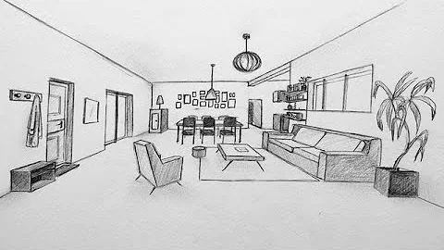
Fluxdeconnaissances.com

a-1. Find out the equivalent in English of the furniture in the room above.

un canapé |  | un confiturier
un fauteuil |  | un lustre
un tapis |  | une table à manger
un pouf |  | une chaise
une table basse |  | une lampe
une plante |  | des tableaux
une étagère à chaussures |  | un porte-manteau

a-2. EOI : Work in pairs . Describe the room above to your friend using the elements given. Swap roles.

b) E.E : It’s up to you ! What about your own favourite room / place?
Write a paragraph describing your favourite room in your dream house.
………………………………………………………………………………………………………………………………………………………………………………………………………………………………………………………………………………………………………………………………………………………………………………………………………………………………………………………………………………………………………………………………………………………………………………………………………………………………………………………………………………………………………………………………………………………………………………………………………………………………………………………………………………………………………………………
Isabelle.Rhalab@ac-poitiers.fr

