SEQUENCE 3 PM – Write a poem ? Of course I can !

Step 3
___________________________________________________________________
- EE : Write a poem in English.

- EOC : Learn your poem and recite it to the class.

Part 1. It’s up to you!!!
Create! Imagine! Write your own poem!

- Using the poetry sequence, express your real talent, you probably underestimate.

- Choose a month or a season you enjoy and create a poem in 4 stanzas, following one of the rhythmic patterns: ABBA- AABB - ABAB.

Stanzas 1 and 2: First, you will describe this month/season: description, your feelings.

Stanza 3: Are this month and this season what they should be today?

Stanza 4 : Share your hopes, worries and feelings about climate change.

- Don't forget to choose a title for your poem and to create a space between each stanza.

- Enter your final work on the computer.

Part 2 . Learn your poem and recite it to the class. Congratulations !
___________________________________________________________________

World Poetry Day – Exhibition in class
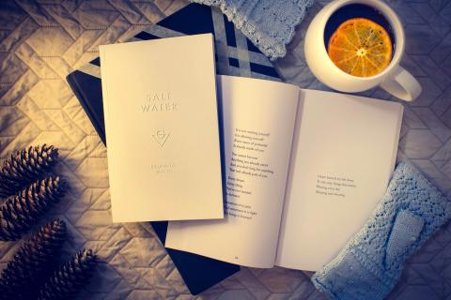
A l'occasion de la journée mondiale de la poésie célébrée le 21 mars et des portes ouvertes du lycée, les élèves de 3 PM de Nelson Mandela School à Poitiers, ont exposé leurs œuvres. Bravo à eux !
Tous nos remerciements également à la professeure d’arts plastiques (IR) de 3 PM pour ce beau projet. Isabelle.Rhalab@ac-poitiers.fr

PROJET INTERDISCIPLINAIRE 3 PM
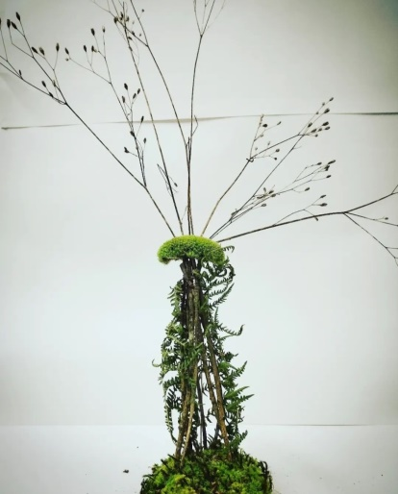 2022 - 2023
August heatwave 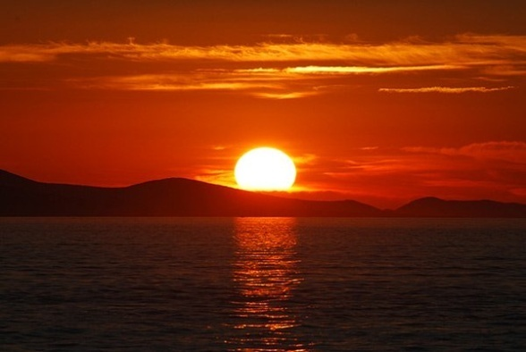
You, month of August
Summer's on your way.
The sign that corresponds to you, dear August,
Is the lion, anyway!
Bright colours dress you. 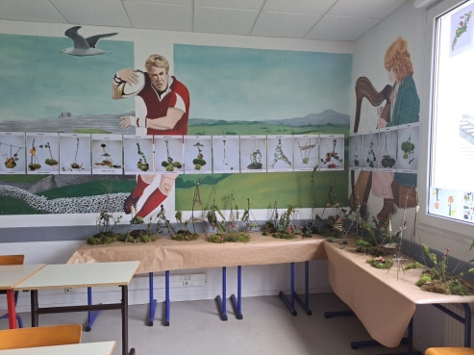
The sun shines, your warmth asserts itself.
The heatwave is coming,
More powerful than before. So surprising !

Isabelle.Rhalab@ac-poitiers.fr
But I believe in you. 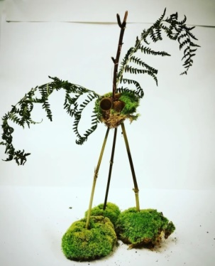
We won't stay under our roofs.
August will return as before,
And that, I'm sure, for a long time to come.
Chloé 3 PM
Thursday 26th January 2023

January

January is a month of good mood

January is a peaceful month

The month of some galettes des rois, so good !

January is the first month of the year

Unfortunately, the climate is changing

Scarves, hats, gloves remain in my board, dying

Cold and frost went on a trip

The snow has disappeared, I would like to see it again

I wish January would come back

Snow, frost and freezing cold, all in a pack

But for that it takes effort, on your side

Stop throwing our garbage outside! 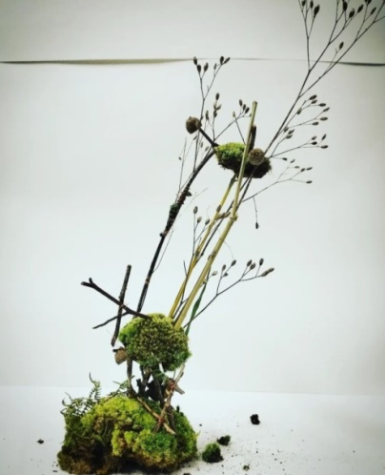

Kilian 3PM

Isabelle.Rhalab@ac-poitiers.fr

In the September light
September, O my dear september
the wind begins to arrive,
Winter is soon upon us, alive
You are back to school month, ô September !

Unfortunately today you are no more,
Like before I really don't recognize you anymore,
You may be the month of retirement,
But it's not the expected moment.

My beautiful month of the year,
Do not lose hope; stay as you are !
Don't despair of seeing you come back,
You will bring back our fondest memories
Anastasia 3 Prépa Métiers – February 2023 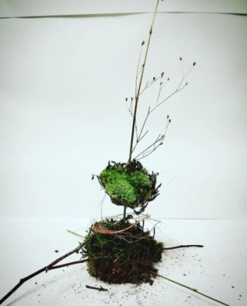

Isabelle.Rhalab@ac-poitiers.fr
Winter is frozen 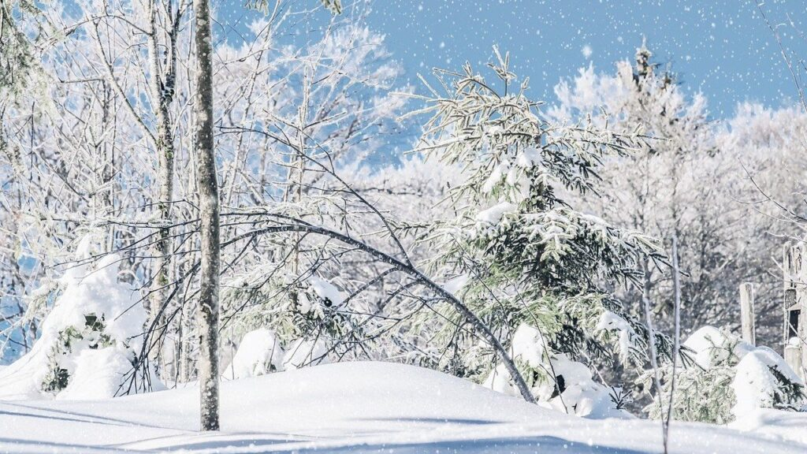
like the tip of my nose
winter has broken
all the people of the year!

Winter had to change
All mankind
But it broke with his joy of living,
All the years to come.

Unfortunately everything disappears
like snow in summer
yet winter is in love
of this vigorous cold, forever.

Jordan 3 p-m

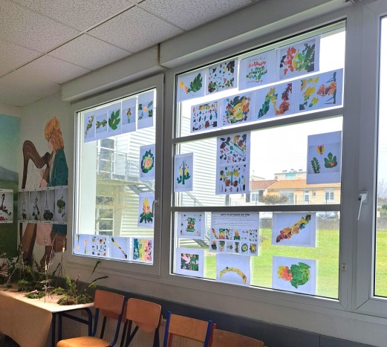 Isabelle.Rhalab@ac-poitiers.fr

