SEQUENCE 3 PM – Write a poem? Of course I can!

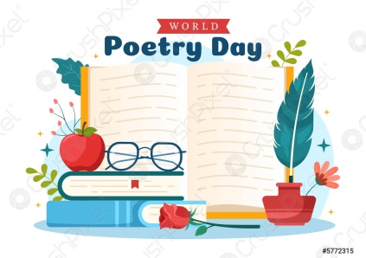 Every 21st March…
________________________________________________________________

Step 1 : Séances intermédiaires – REVIEWS

Part 1.

What about the British isles, the United – Kingdom, Great-Britain?
___________________

1. What languages are you studying this year?
…………………………………………………………………………………………………..

2. What are the capital cities of …? Link the correct answers.

The United Kingdom o o Canberra
Italy o o Washington
Spain o o London
Germany o o Pretoria
The USA o o Brasilia
Brazil o o Wellington
South-Africa o o Rome
Australia o o Madrid
Ireland o o Berlin
New-Zealand o o Dublin

3. Do you know the corresponding nationalities for each country?

Check you know some nationalities. Place these words into the right column

Countries - Nouns | Nationalities - Adjectives
I’m from ……………………….. | I am …………………………
I’m from ……………………….. | I am …………………………
I’m from ……………………….. | I am …………………………
I’m from ……………………….. | I am …………………………
I’m from ……………………….. | I am …………………………
I’m from ……………………….. | I am …………………………
I’m from ……………………….. | I am …………………………
I’m from ……………………….. | I am …………………………
I’m from ……………………….. | I am …………………………
I’m from ……………………….. | I am …………………………

Congolese - Irish - France – English – Italy – Morocco – Spain – Portugal – Scotland – Welsh – French – Spanish – England – Italian – Moroccan – Portuguese – Ireland – Wales – Scottish – Congo
- Vous remarquerez que les noms propres, tout comme les adjectifs liés à la nationalité, prennent une MAJUSCULE en anglais.

4. Among the names given above, 3 are not countries but regions, themselves made up of counties.

What are these 3 regions (Noun + Adjective)?
…………………………………………………………………………………………………………………………………………………………………………………………………….

To which country do they belong?
…………………………………………………………………………………………………..

5. What are the British Isles composed of ?
…………………………………………………………………………………………………..
6. What about the United Kingdom ?
…………………………………………………………………………………………………..
7. Great Britain ?
…………………………………………………………………………………………………..
8. Who is the King of The United-Kingdom ? Who was the Queen before him ?
…………………………………………………………………………………………………

9. Complete the map.

a) Circle the British Isles in blue.
b) Circle the United Kingdom in red.
c) Circle Great Britain in green.
d) Colour England yellow and write its capital.
e) Colour Scotland purple and write its capital. 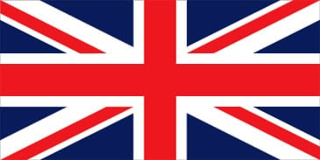
f) Colour Wales orange and write its capital.

Isabelle.Rhalab@ac-poitiers.fr

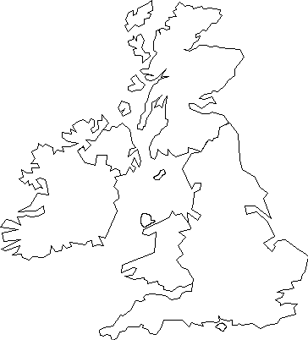

Part 2. What is the weather like today ?

1. Listen carefully to the weather forecast and pick out the vocabulary you need to understand it. Find adjectives with opposite meanings. Then learn them !

https://learnenglishteens.britishcouncil.org/skills/listening/a2-listening/weather-forecast

……………………………………………………………………………………………………………………………………………………………………………………………………………………………………………………………………………………………………………………………………………………………………………………………………………………………………………………………………………………………………………

Debate ! EOI
2. Is this the weather we should be having at this time of year? Yes or no? Why or why not ?

3. Give your opinion on climate change . You can use the words below.

Help ! = No choice - frightened - afraid - hopeful - optimistic - pessimistic - normal - abnormal - accept - refuse - saddened - enjoy

Part 3 - Normal seasons?

1. Draw what the 4 seasons represent and write down the corresponding vocabulary :
a snowman - the leaves are falling - the sun is shining - the wind is blowing - the wind is blowing - clouds - snowflakes - sand - the sea - frost - it's mild, warm - it's cold and windy - it's freezing - it's hot - heatwaves - flowers

2. What should you wear in each season? ( Clothes – accessories)
Isabelle.Rhalab@ac-poitiers.fr

3. Now write the 3 months corresponding to each season.

Drawing my 4 seasons

Season1 : Season 2 :

Months : Months :
Season 3 : Season 4 :

Months : Months :

Isabelle.Rhalab@ac-poitiers.fr

