Séance 2
Eye makeup tips from Maybelline

Shimmer eyeshadow makeup tutorial

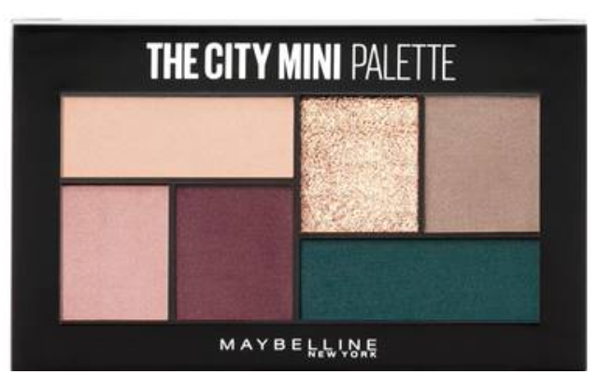

Step 1 : Apply the palette’s lightest shade over the entire eyelid (from the inner corner to the outer corner of the eye) to create a neutral base.
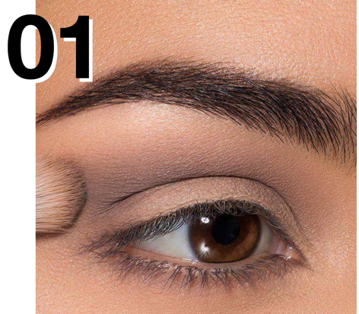
Step 2: Pat the gold glitter eyeshadow onto the center of the lid for a glistening effect.
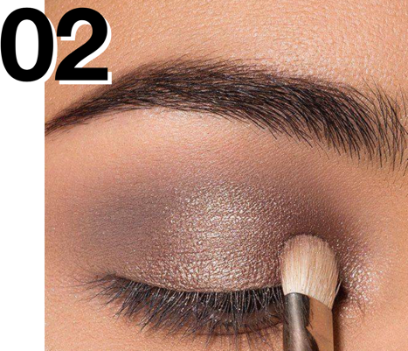

Step 3: Apply the palette’s purple eyeshadow along the outer corner of the eye in a V shape. Blend into the top lash line and crease of the lid.
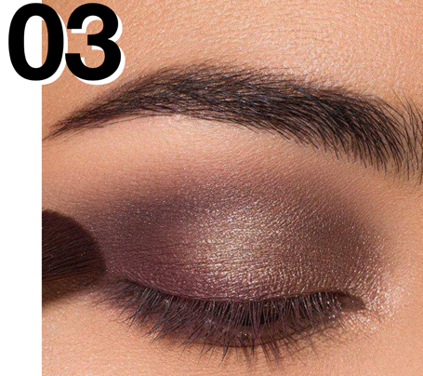
Step 4 : Finish the look by adding smooth, clump-free volume to your lashes with Snapscara mascara in ‘Pitch Black.’

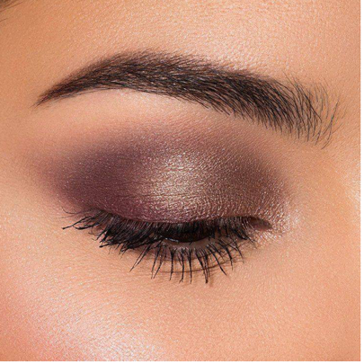

Find the english translation of the following words.
Appliquer : __________________
La couleur la plus claire : ____________________
Sur : ___________
La paupière (deux mots) : _________________________
Pour créer : __________________
Tapoter : _________________
L’ombre à paupières : _________________
Un effet brillant : _____________________
Le long : _______________
Le coin externe : ____________________
Estomper : _________________
La ligne des cils : ___________________
Le creux de la paupière : ___________________________
Ajouter : _________________
Lisse : _________________
Sans paquets : __________________
Les cils : _____________________

In your opinion, what do the following words mean?
The inner corner : ___________________
From… to… : ___________________
Purple : ___________________
Onto : _______________

Now, choose your favourite palette and write a tutorial. (you can use the sentences from the document above)
_______________________________________________________________________________________________________________________________________________________________________________________________________________________________________________________________________________________________________________________________________________________________________________________________________________________________________________________________________________________________________________________________________________________________________________________________________________________________________________________________________________________________________________________________________________________________________________________________________________________________________________________________________________________________________________________________________________________________________________________________________________

