Part 3: Same player ? Shoot again !

Je suis capable de rédiger une brève description d’un personnage de jeu vidéo et/ou sur lesuperpouvoir que j’aimerais avoir. (A2-A2+)

→ Listen to complete:

Character Game Nationality

→ Circle what you hear:

a) Her job: a soldier an archaeologist a treasure hunter

b) Her personality: powerful athletic brave intelligent sporty determined

c) Her appearance: brown eyes blue eyes brown hair black hair a braid a ponytail

→ Fill in the blanks with the following words:

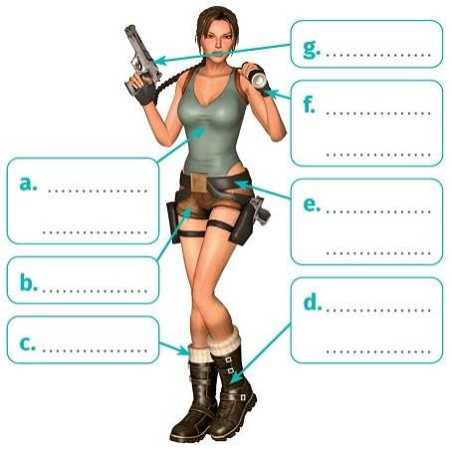
A tank top - shorts - combat boots - socks -

ﬁngerless gloves- pistols - a utility belt

→ Write a text in English to explain which superpower would be your favourite:

I imagine I have … ____________________________________________________

___________________________________________________________________

___________________________________________________________________

___________________________________________________________________

___________________________________________________________________

___________________________________________________________________

___________________________________________________________________

→ Listen to the presentation to complete it:

“I’m going to ________ about John Price ________ he is my favourite video gamecharacter. He is the main character in Call of Duty. First, I like his appearance and his personality.He is very tall. He has brown hair ________ blue eyes. He has army clothing and he is serious.Then, I ________ he is incredible. He is very strong. For ________, he can ﬁght very wellwith his weapons. He is an excellent soldier. To conclude, in my ________, he is the best videogame character !”

→ Surlignez dans le texte ci-dessus les 3 éléments qui structurent la prise de parole.

→ A retenir !

Pour structurer une prise de parole

-
Pour expliquer un propos

-
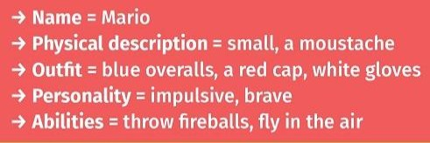
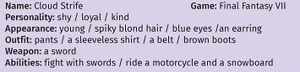
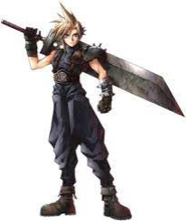

Je peux écrire des expressions sur le lieu de vie d’un personnage de jeu vidéoou sur le personnage lui-même avec de l’aide. (A2-A2+)

→ Present orally this character using the elements below and the example above:

For ne t i : _____/_____/_____

1 - R e c o r d ( M P 3 ﬁ l e p l e a s e ) t h e p r e s e n t a t i o n o f t h i s c h a r a c t e r :

2 - R e a d t h e f o l l o w i n g t e x t t o w r i t e a r e p o r t i n F r e n c h :

“ Link is the main protagonist of the Legend of Zelda series [...] The various heroes who use the name Link are courageous young boys or teenagers, often in green clothing, who leave their homes to save the world from evil forces. [...]
He usually has light-coloured hair (ranging from brown to blonde to orange), blue eyes and a medium build. [...] In promotional material for Breath of the Wild, Link wears the Champion’s Tunic and a simple pair of Hylian Trousers. [...]
He is implied to be somewhat sleepy or lazy. [...] Link possesses basic characteristics found in a heroic character: bravery, compassion, determination, and wisdom. [...]
Link is remarkably proficient with a wide variety of weapons, instruments, and other items, being able to use them immediately upon obtaining them. His preferred weapons of choice though, are swords. In each of his adventures, Link’s primary form of combat becomes sword fighting, usually with a shield. “

https://zelda.fandom.com

● Implied to be somewhat: on sous-entend qu’il est un peu… ● Wisdom: sagesse
● Upon obtaining them: quand il les obtient

