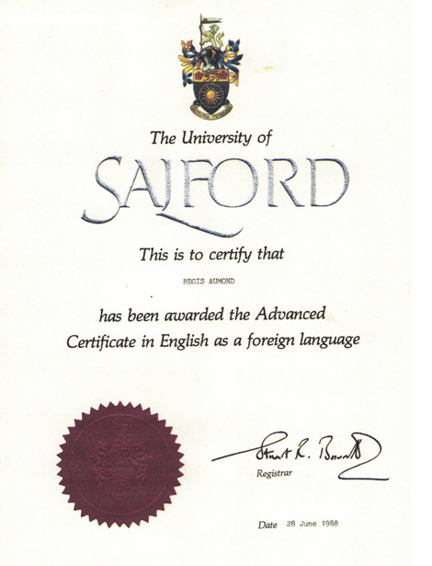
My “pretty”degree, full of colours!

