Extra exercises:

→ W a t c h t h e vi d e o t o co m pl et e t he f oll o w in g exe rci se s:

https://vimeo.com/566617729/b67a08a445

1- Circle the correct elements:

a) The game is a (racing/shooting/strategy) video game.

b) The action takes place (in the past/ in the present/ in the future).c) The main character is a middle-aged (man/woman).
d) The character ﬁghts (spiders/creatures).

2- True (T) or False (F) ?

a) The character is a pilot ?

b) The character uses a spaceship ?

c) The landscape is composed of beaches and lakes ?d) The planet is di erent every time she dies ?

3- Fill in the blanks:

a) Over and over I relive my ﬁrst moments on this ___________ planet:

the crash, the __________, my death.

b) Trapped in this endless cycle, even death is no __________ .

c) This __________ is becoming part of me, infecting my mind, mymemories.
d) But I __________ lose hope. My only choice is to keep __________ .

→ Use language tools:

- Use be in the present tense in the negative (-) or positive (+) form:

a) I _____ fond of video games. (+)

b) My favourite game _____ Minecraft. (+)

c) The landscape _____ incredible. (+)

d) We _____ video game addicts! (+)

- Complete with is or has:
e) The game _____ di cult. (-)

f) The characters _____ funny. (-)

g) But they _____ realistic. (-)

h) The plot _____ interesting. (-)

a) Who ___ your favourite character ?

b) He ____ short brown hair.

c) He ____ intelligent and courageous.
d) He ____ blue eyes.

e) He ____ young.

f) He ____ a beautiful outﬁt.

- Observe the cards to circle the right answer :

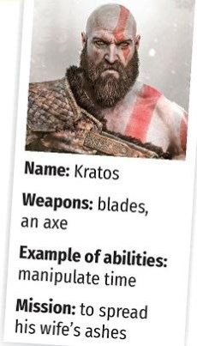
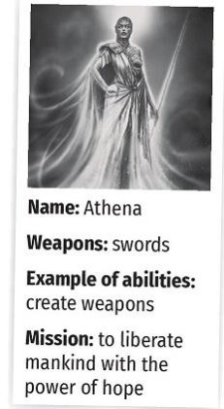
a) (His/her) name is Kratos.b) (His/her) name is Athena.

c) (His/her) main weapons are bladesand an axe.
d)( His/her) weapons are swords.

e) (His/her) mission is to spread(his/her) wife’s ashes.
f) (His/her) mission is to liberatemankind* with the power of hope.

g) Athena (can/can’t) create weaponsbut she (can/can’t) become invisible.

→ TIME TO PLAY ! Student 1 chooses a character and Student 2 asks questions.

