The Pass It on Movement
Jamie Oliver asks French people to help him out teaching simple and healthy recipes to English people (to include in his programs).
Warming up activities

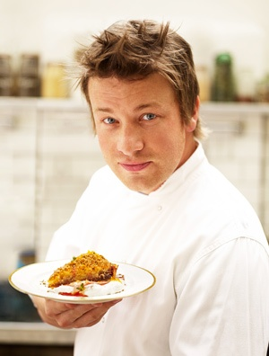
Who is Jamie Oliver?
Discuss
Can you cook?
What can you cook?
Do you have a healthy lifestyle?
Have you heard about Jamie Oliver?
Find out about his activities in the following mind map

Step one
Who is Jamie Oliver?

Projects  http://www.jamieoliverfoodfoundation.org.uk/activities | Tv Shows  http://en.wikipedia.org/wiki/Jamie_Oliver#Television_shows | Restaurants  http://www.jamieoliver.com/restaurants/#aDSZg83mhlovcmuy.97 | Magazine  And books  http://www.jamieoliver.com/recipes/category/books/#fLgxGJK6LCalRk4i.97
The fifteen project  School dinners  The Ministry of Food  Food Revolution  Jamie Oliver Food Foundation | The naked chef  Oliver’s Twist  School Dinners  Jamie At home  Jamie’s Ministry of Food  Food revolution | Fifteen  Jamie’s Italian  Recipes  Jamie Oliver’s dinners  Barbecoa  Union Jacks | Jamie Magazine
Choose one of his restaurants or projects or shows. Do some research and present what you’ve learnt to the class.

