Doc. 1

King Charles's 15 Countries: The Commonwealth Realms

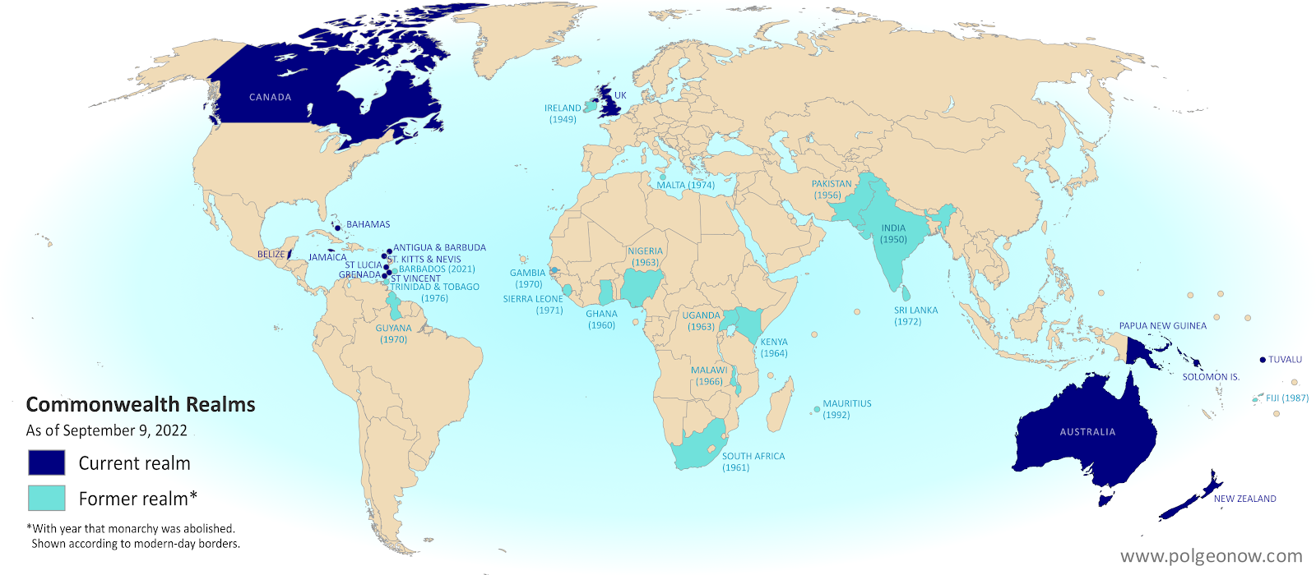
Map of the Commonwealth realms (independent countries that share the monarchy with Britain).

