After a football match at the Camp Nou

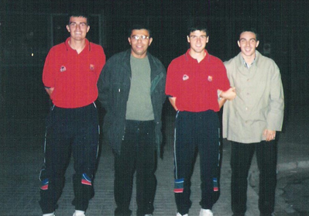
From left to right : Oscar Garcia, Régis Aumond, Roger Garcia and Marc Machado Pena

