Part 2: How do protest songs become iconic ?

→ Work in pairs to ask questions and answers with the helping file.

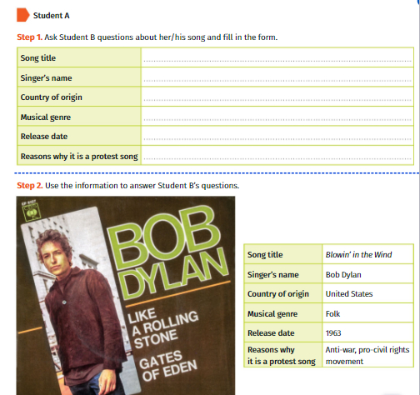

→ Work in pairs to ask questions and answers with the helping file.

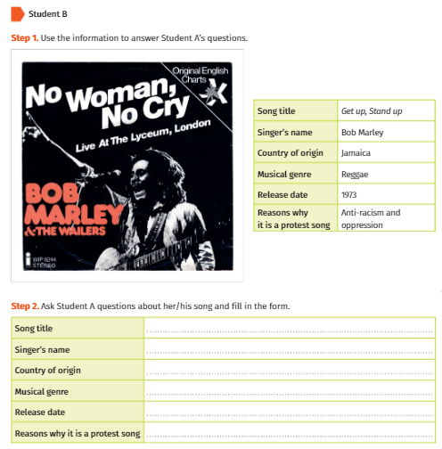

→ In 5 to 8 lines in English, tell what makes a protest song an iconic song.

