Part 4: Convey views and emotions…

→ Observe the document to place the elements here : source-titre-auteur-date-sous- titre
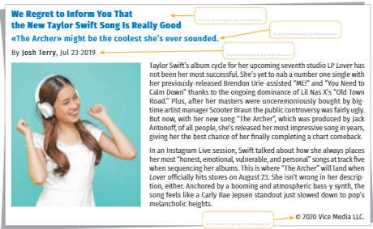

→ Explain orally, in French, what you understood from the text above or the criticism below.

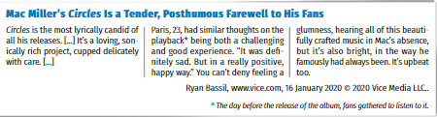

→ Listen to the video “Macklemore & Ryan Lewis Same Love”.

- The title of the song is “Same Love” OR “A Single Love” OR “Different Love”.
- The singer is Eminem OR Macklemore OR Mickael Jackson.
- The song is about the life of a woman OR a man OR children.
- The lyrics are pessimistic OR optimistic OR realistic.
- The message supports love OR domestic violence OR the anti-war struggle.
- The genre of the song is rock and roll OR pop OR rap.

→ Watch the video https://vimeo.com/566944596/53ea49a37b to give your opinion with the following words :
in my opinion- I think that - as far as I am concerned - for me.

→ Complete the text below with these words :
because of - due to – I believe - that’s why.

- Clara : I _______________ that the songwriter knows the subject deeply. The song is all the more moving ________________ the inspired lyrics.

- Kate : I agree with you ! I must admit that ________________ the intensity of the lyrics, his voice performance stands out and _______________ I really love the song.

→ Choose one subject to write a 5-8 line answer in English :

- Do you know charities organizing concerts to raise funds ? Have you ever been committed to a charity ? Please develop your answer.

- You receive a message from a client who complains about how he was welcomed in your company. Please answer him and suggest some improvements.

