**JUNE 10, 2022**

**ENGLISH BREAKFAST AT JEAN JAURES SCHOOL!**

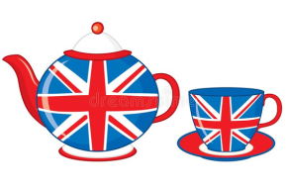

1. **MATCH THEM UP! *(Ecris le mot qui correspond à l’illustration)***

|  |  |  |  |  |
| --- | --- | --- | --- | --- |
| **a scone** | **a cup of tea** | **sugar** | **honey** | **butter** |
| **a toast** | **marmelade** | **an apple** | **a muffin** | **milk** |

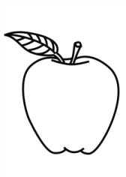**1-…………………………… 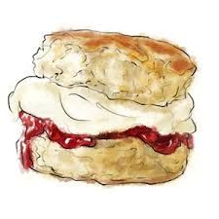2- …………………………………** 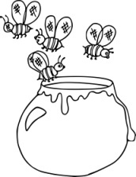**3-……………………………………**

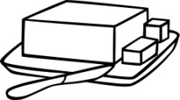**4-………………………………………… 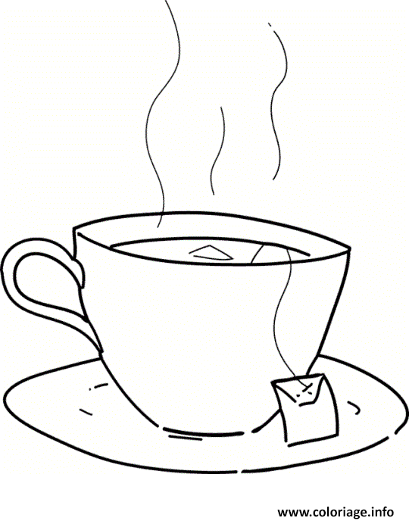 5- ………………………………………………….**

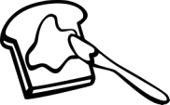**6- ……………………………………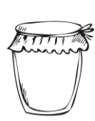7-……………………………………… 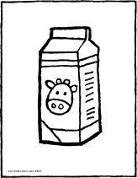 8- …………………………**

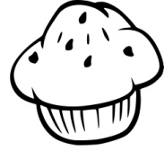**9- ……………………………………… 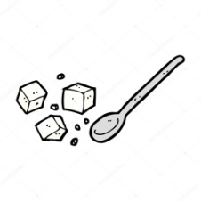10-…………………………………**

1. **I LIKE** https://cdn.onlinewebfonts.com/svg/img_420427.png **/ I DON’T LIKE** 

|  |  |
| --- | --- |
| **https://www.coloori.com/wp-content/uploads/2016/10/coloriagemuffin.jpg** |  |
| **https://st.depositphotos.com/1742172/3816/v/950/depositphotos_38164243-stock-illustration-cartoon-sugar-lumps-and-spoon.jpg** |  |
| **https://kiddicoloriage.fr/wp-content/uploads/2017/06/une-brique-de-lait-coloriage-dessin-image-%C3%A0-colorier-01V.png** |  |
| **https://i.pinimg.com/originals/d4/c4/0a/d4c40a5592fb062e9b0b9d50306dee0b.jpg** |  |
| **https://www.coloori.com/wp-content/uploads/2016/03/beurredessin.jpg** |  |
| **https://coloriage.info/images/ccovers/1496431213tasse-de-the.gif** |  |
| **https://clipartmag.com/image/bitten-apple-drawing-38.jpg** |  |
| **https://www.coloori.com/wp-content/uploads/2016/09/coloriagetartine.jpg** |  |
| **https://i.pinimg.com/originals/4c/14/94/4c1494cfe6b4d828f6955b069a06ac28.jpg** |  |
| **https://www.coloori.com/wp-content/uploads/2016/05/coloriagemiel.jpg** |  |