DEVONPORT HIGH SCHOOL
http://www.dhsb.org

On the homepage

Where is Devonport High School? Name the city: .....................................................................

Is it a mixed school? YES NO Justify your answer: .................................

Click on School tour. Name the buildings:

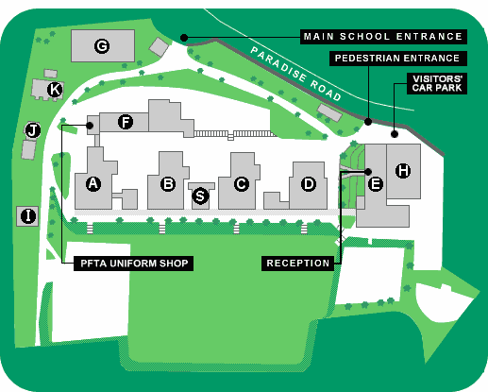 | A. ...........................................................  B. ...........................................................  C. ...........................................................  D. ...........................................................  E. ...........................................................  F. ...........................................................  G. ...........................................................  H. ...........................................................  I. ...........................................................

Click on each building and find out where the following subjects are taught. Write the correct letter.

Science: ........ History: ........ Geography: .......... Foreign languages : .........

Art: .......... PE: .......... Music : ........... English : ...........

Where are they? Write the letter.

The library: ........ The main staff room : ........... The refectory: .........

Click on School Information.

What's the English for...? Premier trimestre: ..................................
Deuxième trimestre : ........................................
Troisième trimestre:.........................................

Who is Mr K J Earley? : ............................................................................................

Click on General School Information.

When do classes start and finish? ................................................................................................

Click here: Describe the school uniform: ...............................................................................
.......................................................................................................................................................
........................................................................................................................................................

